**Section 16 ) AWS Integration and Messaging : SQS , SNS and kinesis**

**Note : if we want to deploy multiple application they need to communicate**

**Introduction to messaging**

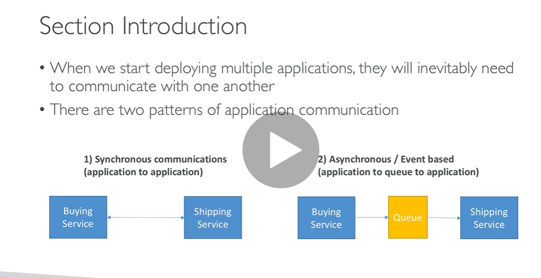

**Synchronous :** directly talking with each other

**Asynchronous :** first put message into queue that someone bought then from queue shipping service will came to know ok someone bought

**Decouple means separate**

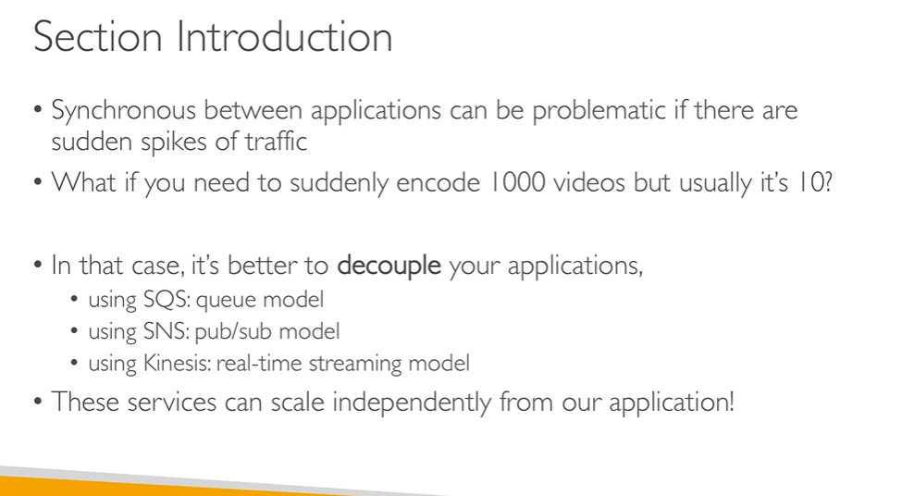

**Amazon SQS standard Queue Overview**

Amazon Simple Queue Service (**SQS**) is a fully managed message queuing service that enables you to decouple and scale microservices, distributed systems, and serverless applications

With **serverless** computing, your **application** still runs on servers, but all the server management is done by **AW**

**Queue service is a buffer or decouple between producer and consumer**

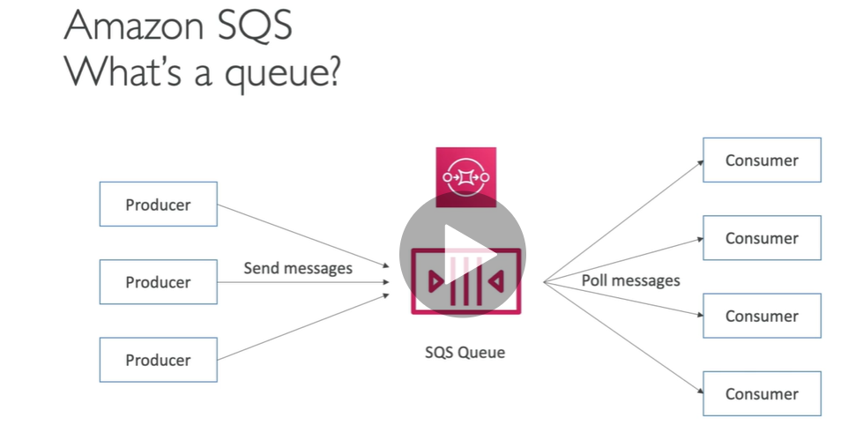

**What is decoupled application?**

In microservice architectures, applications are built and deployed as highly decoupled, focussed services. A decoupled application architecture allows each component to perform its tasks independently - it allows components to remain completely autonomous and unaware of each other

**Note :**

No limit in no of message in queue

By default message in queue min 4 days and max 14 days

We get response from queue in less than 10 ms( publish and receive)

256 Kilobyte

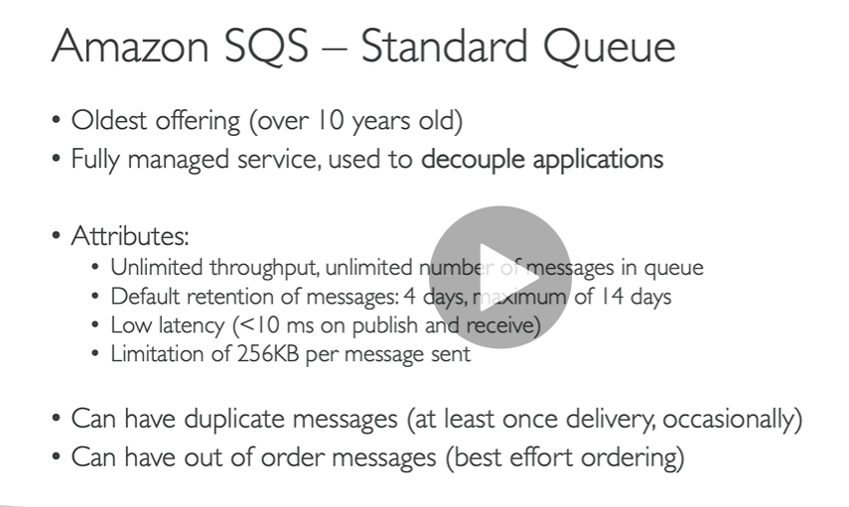

SDK : **software development kit**

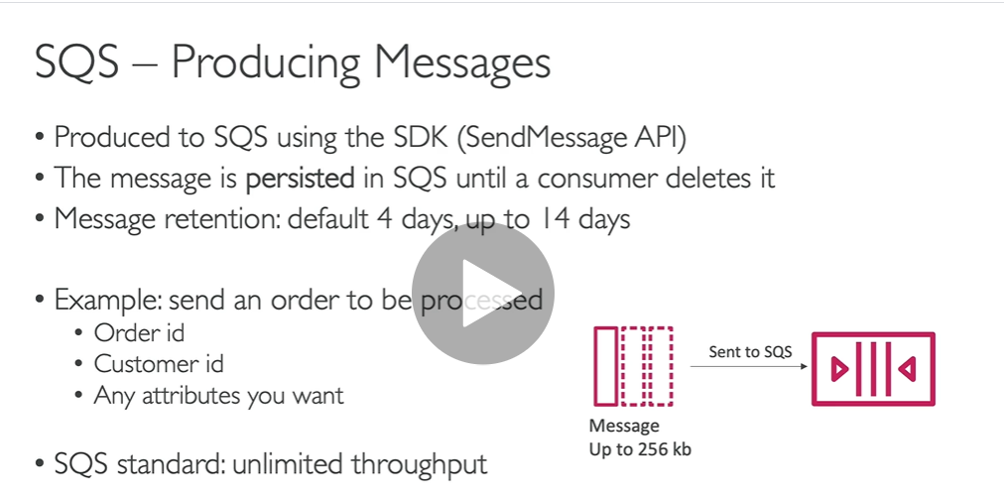

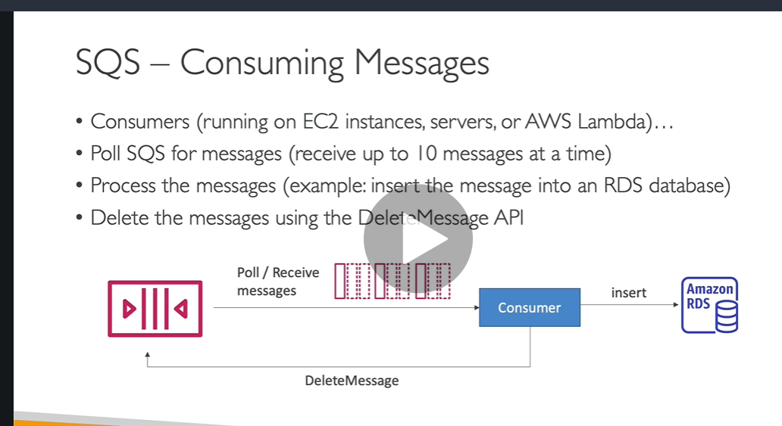

NOTE:

**Consumers receive different set of messages**

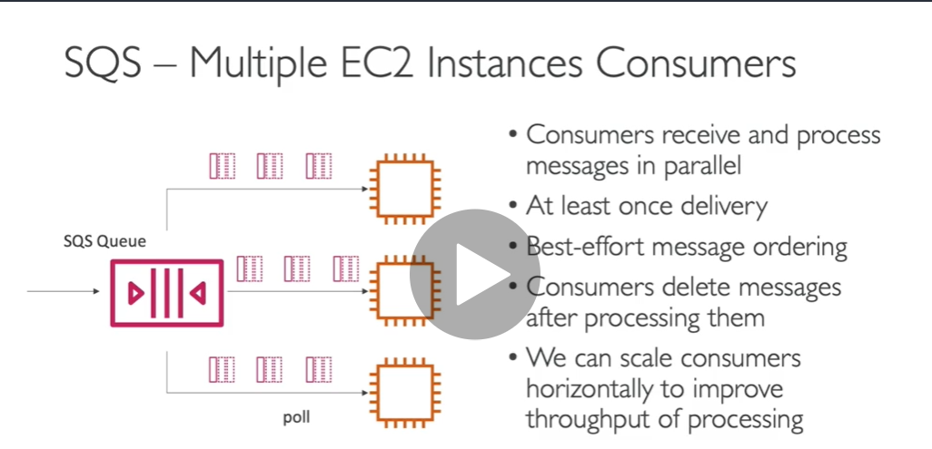

Important

Consumer is running in autoscaling group and when queue length increase then it will raise alarm and due to autoscaling group ec2 instance will increase and throughput will increase

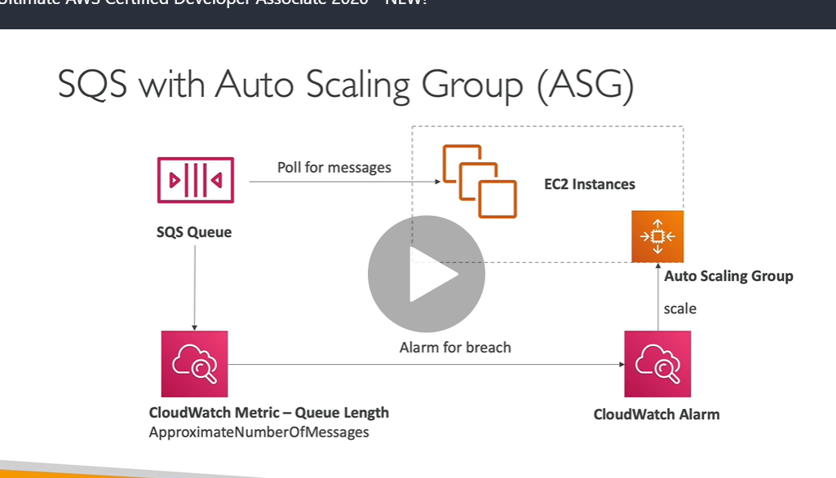

Note:

**Requirement need to process video**

**To frontend request will come and and it pass to sqs then backened will process and insert it into s3 ( here application are independent with each other)**

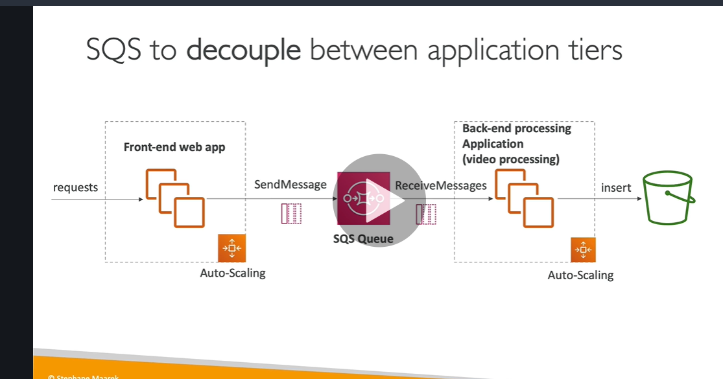

**We can use for frontend(optimal type ec2 instance) and backend ( gpu -graphical processing unit)**

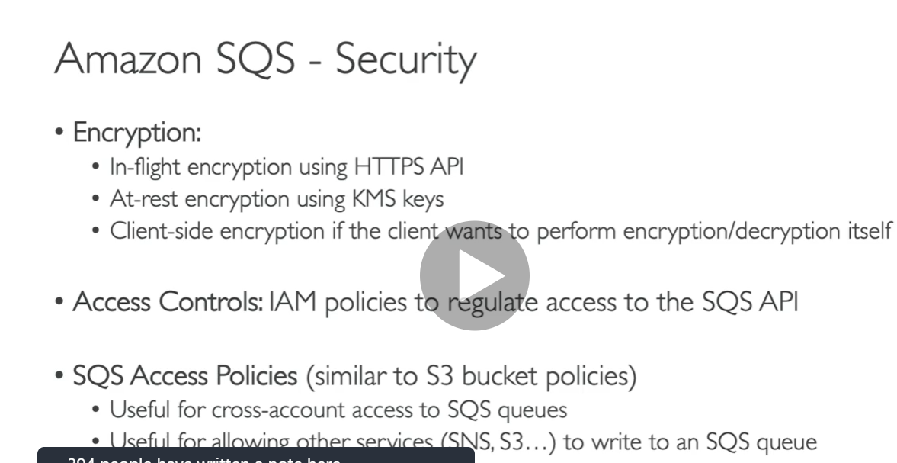

**SQS :- standard queue hands on**

**Step:)**

**Go to SQS service**

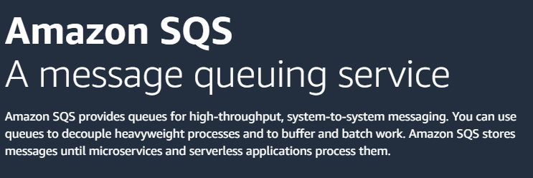

**Click create queue**

**Note:**

**we can define configuration of message in queue**

**Access policy : who will access message**

**Default : queue owner**

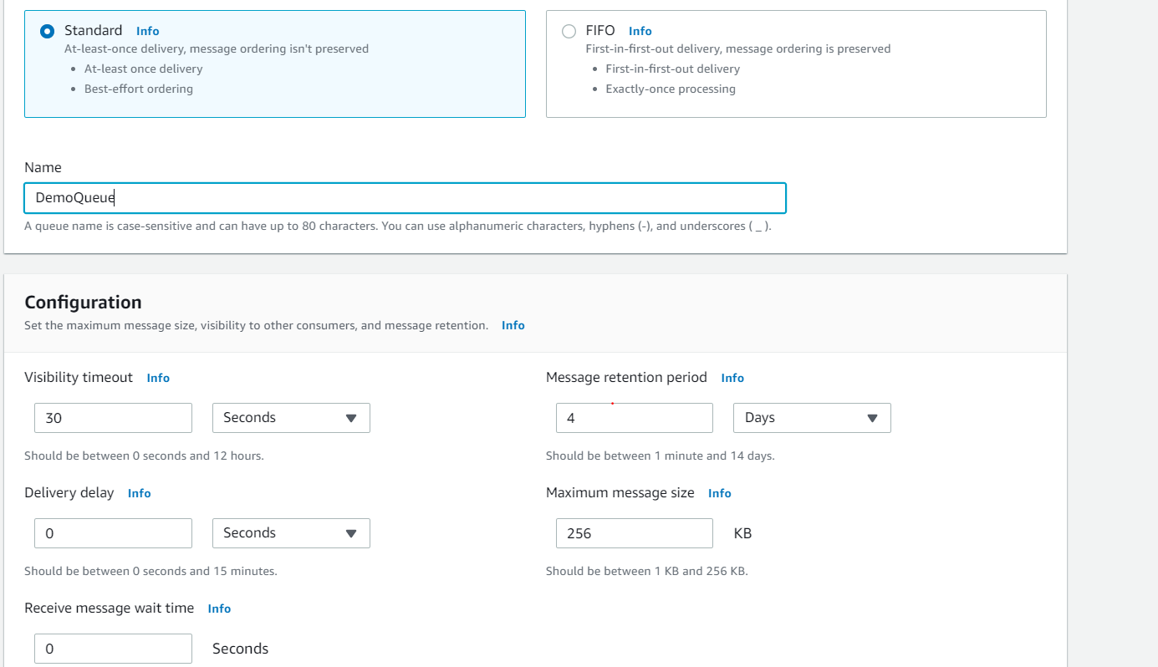

**It is very helpful when we need to integrate with SQS or ec2**

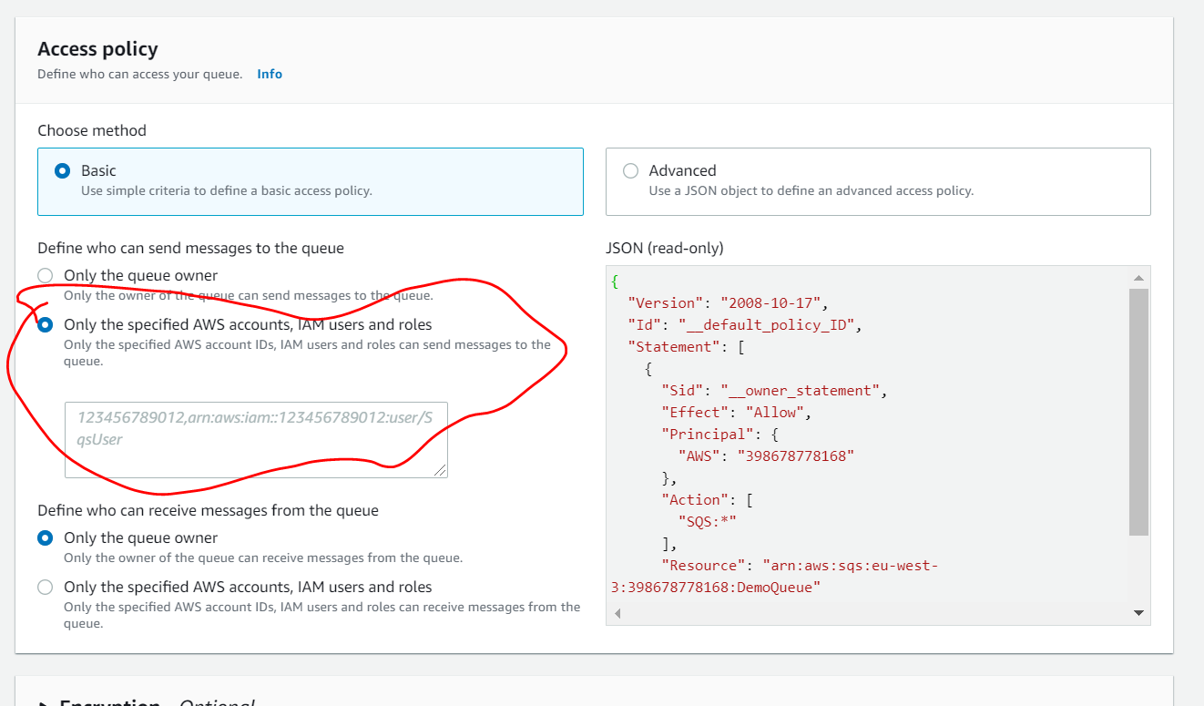

**As of now basic**

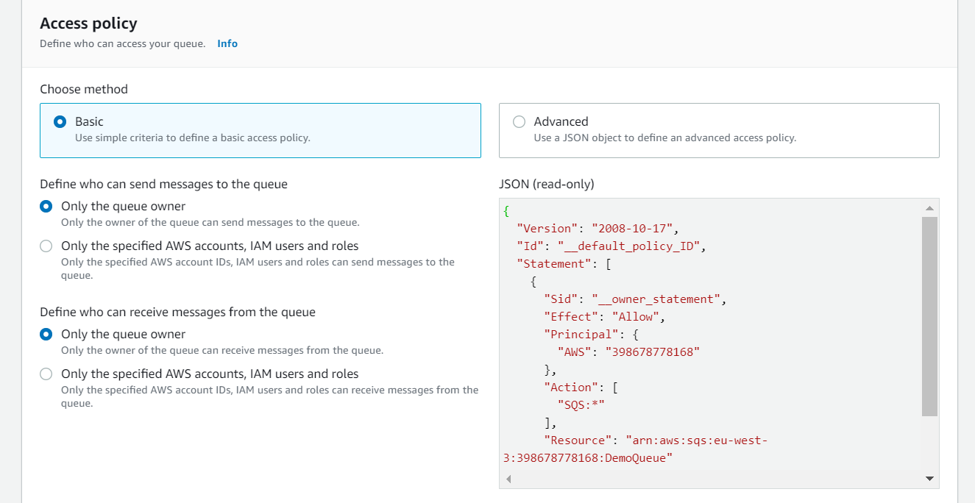

**Click on create queue**

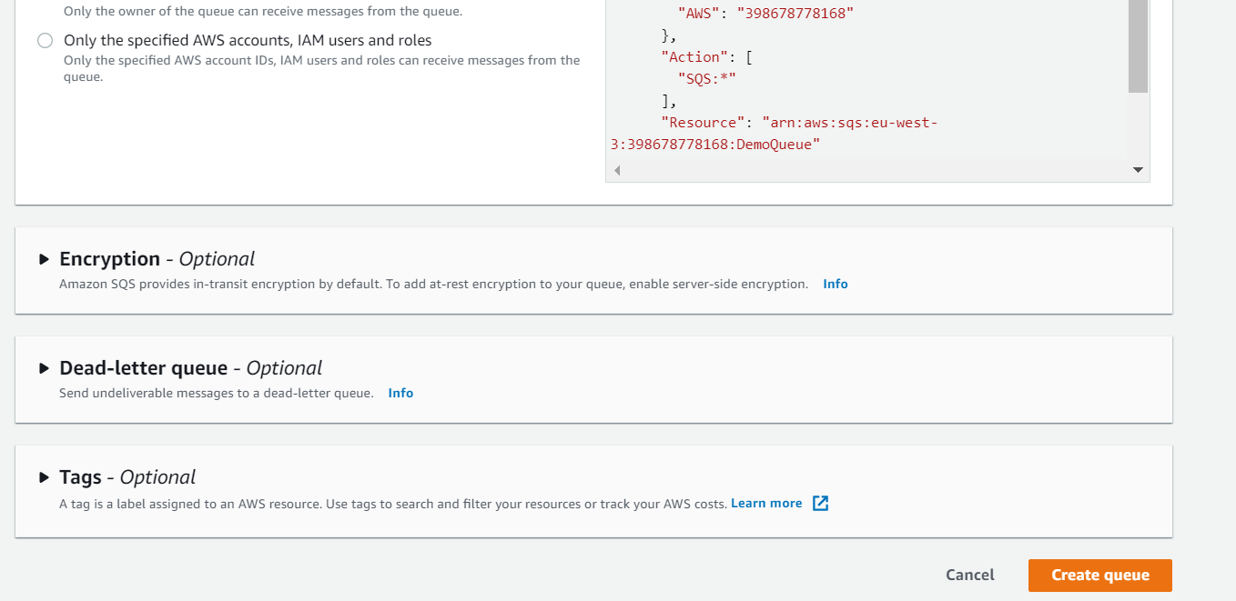

**Queue created click on send and receive message**

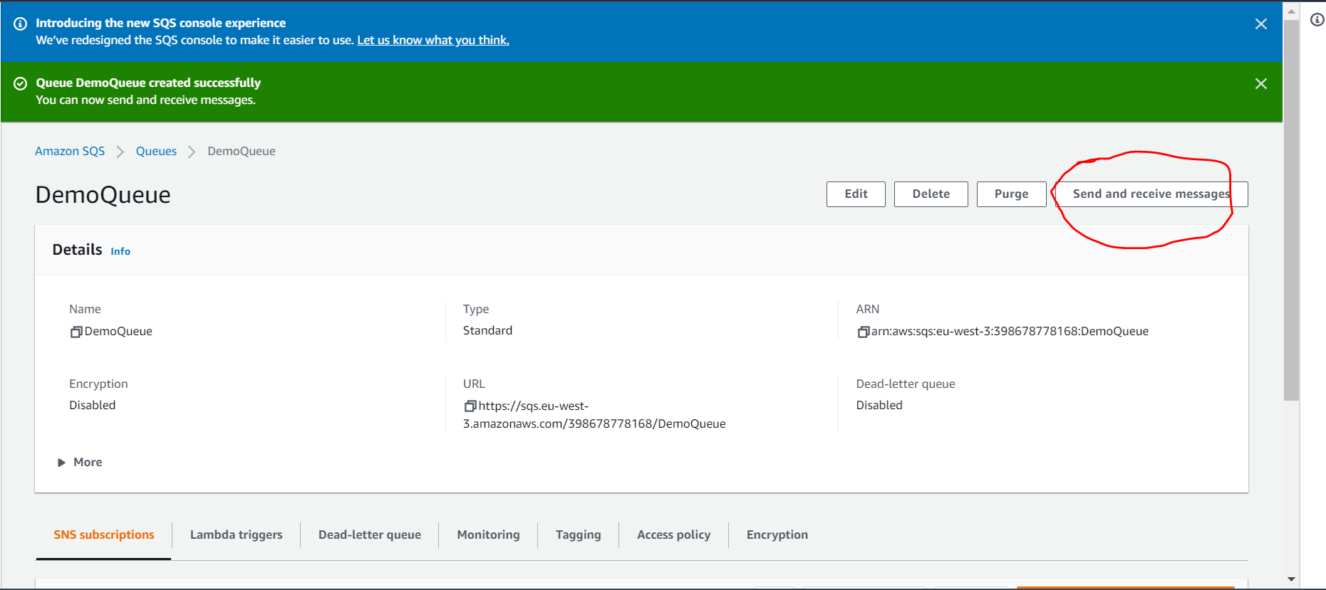

**Want to send message then write in message body and click on send message**

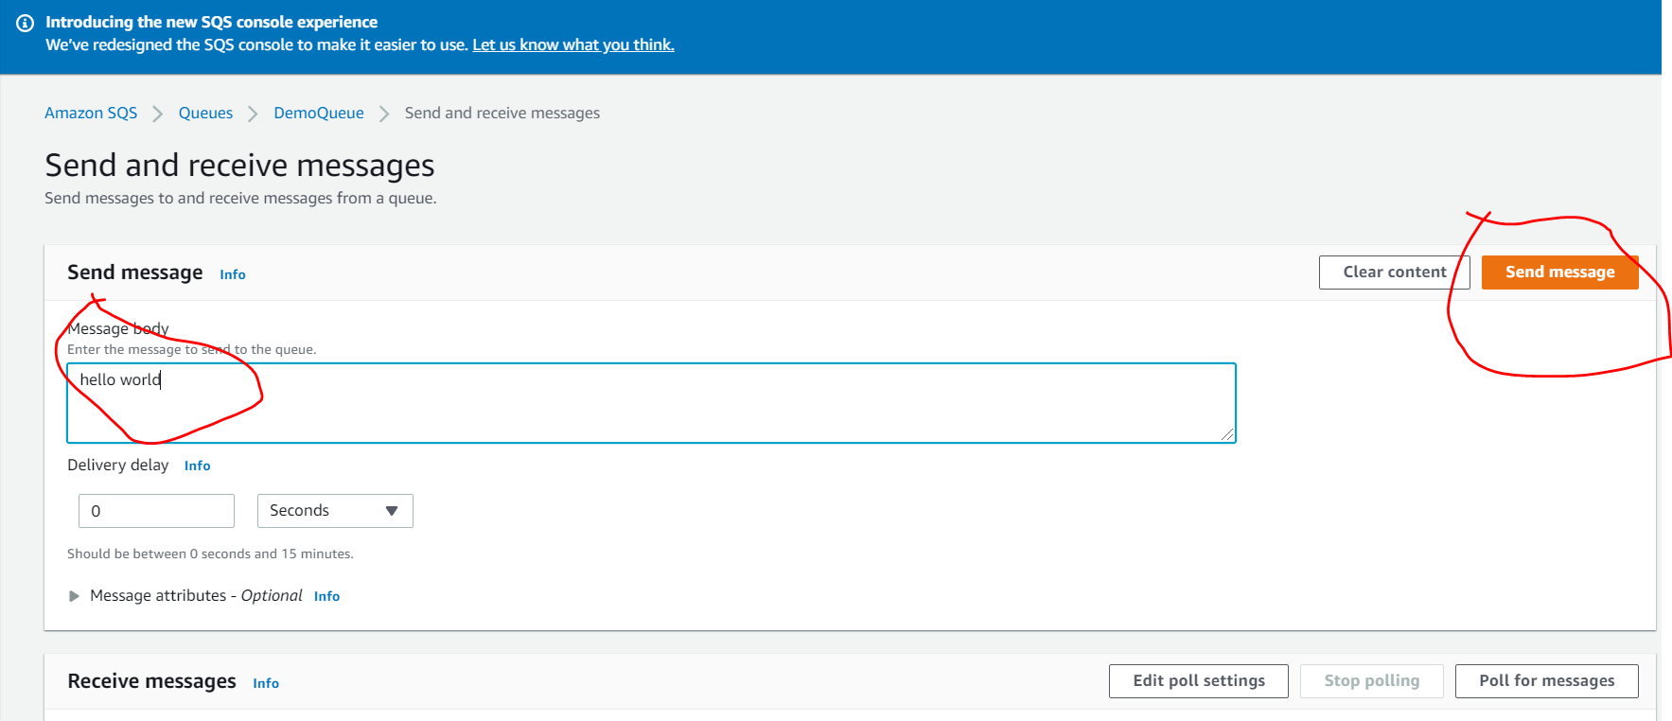

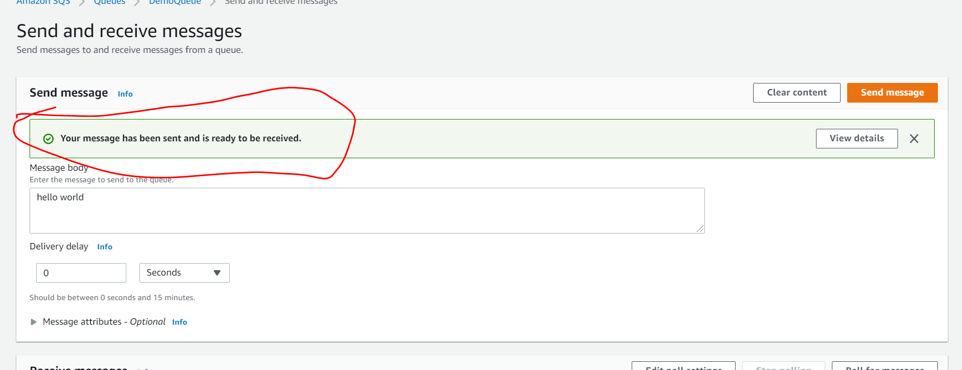

**To receive a message we need to click poll for message**

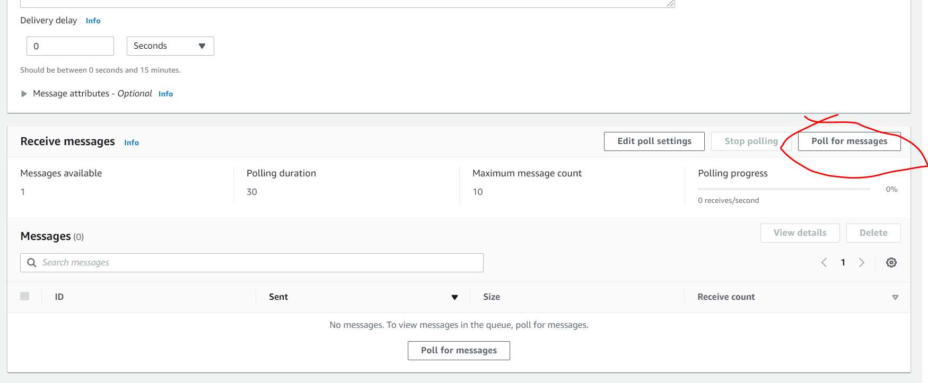

**Message will received as a id click on that**

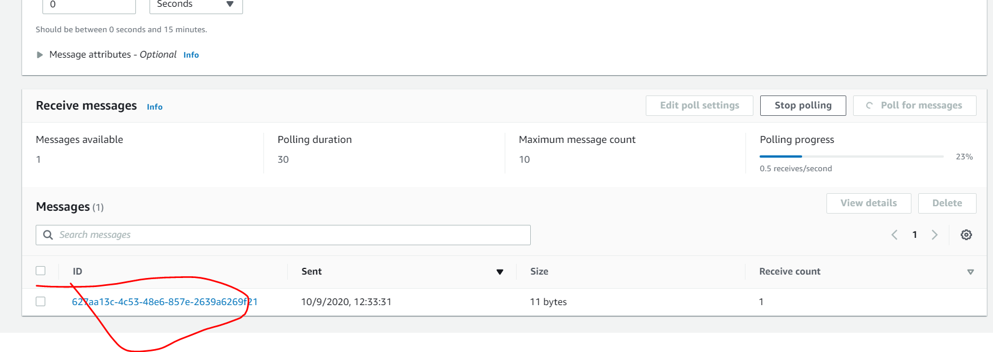

**Want to see message click on body**

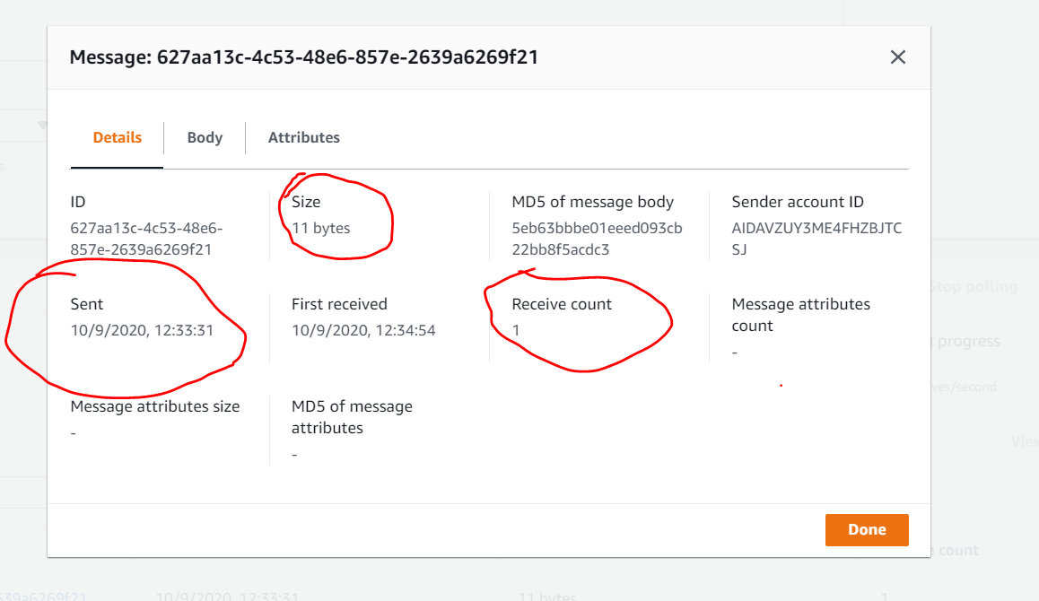

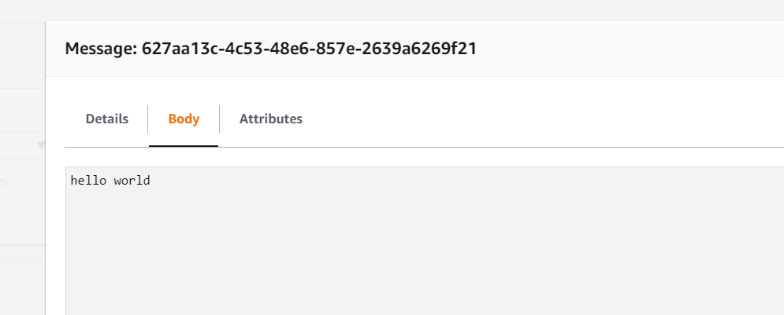

**Note :**

**If message is deleted from receiver we can't poll again**

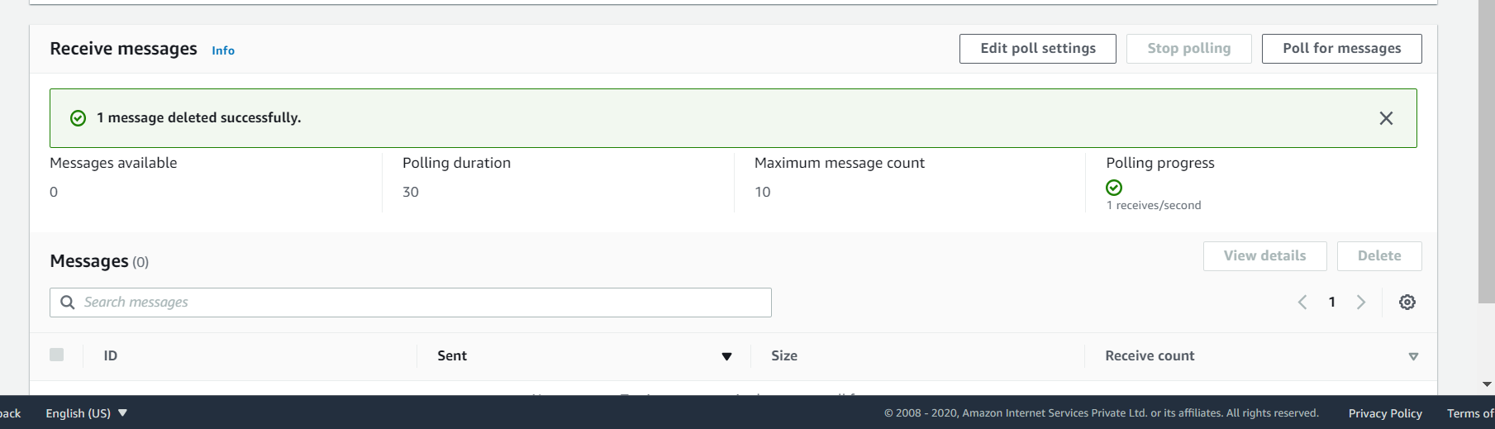

**Note :**

**We send three message from sender so after polling three message are available as soon as we process it then delete message**

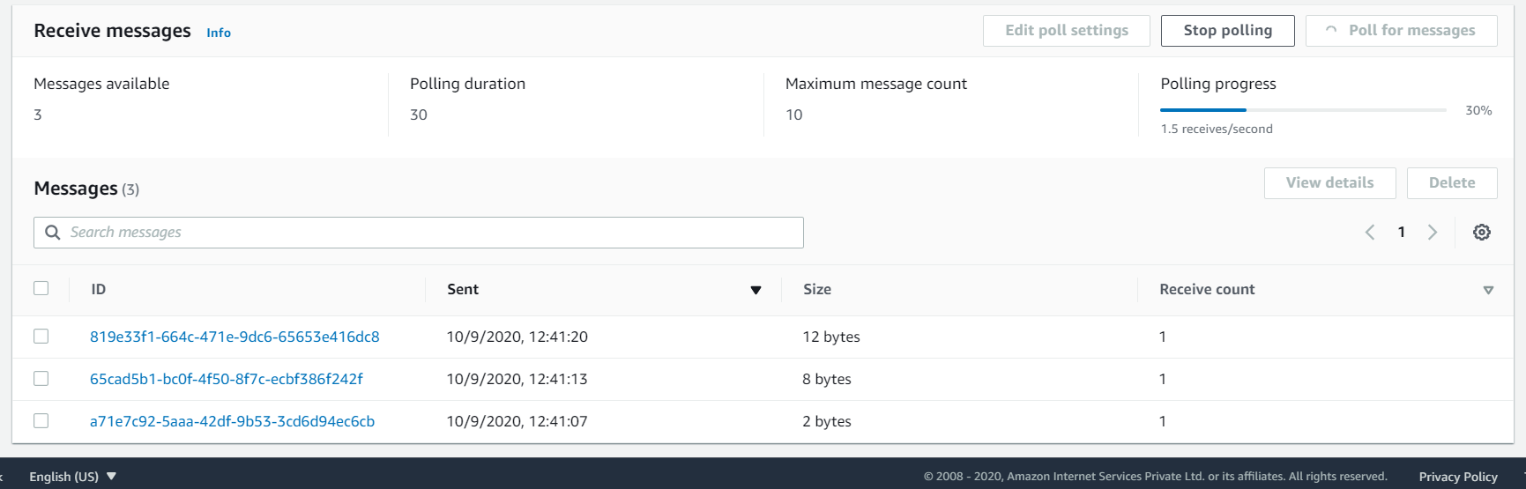

**Once message deleted the message available will show 0**

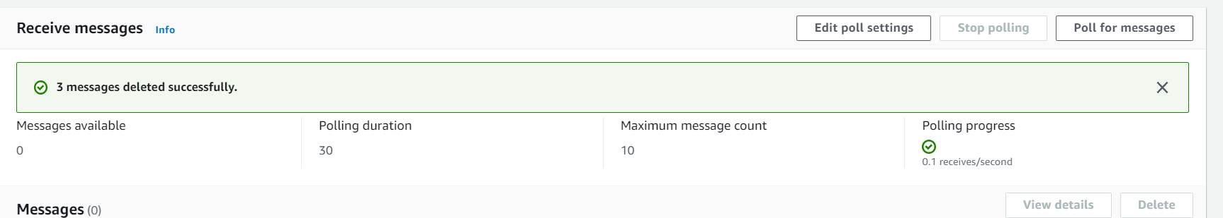

**Note :**

**Edit will do edit of configuration of queue**

**And purge will delete all message in queue**

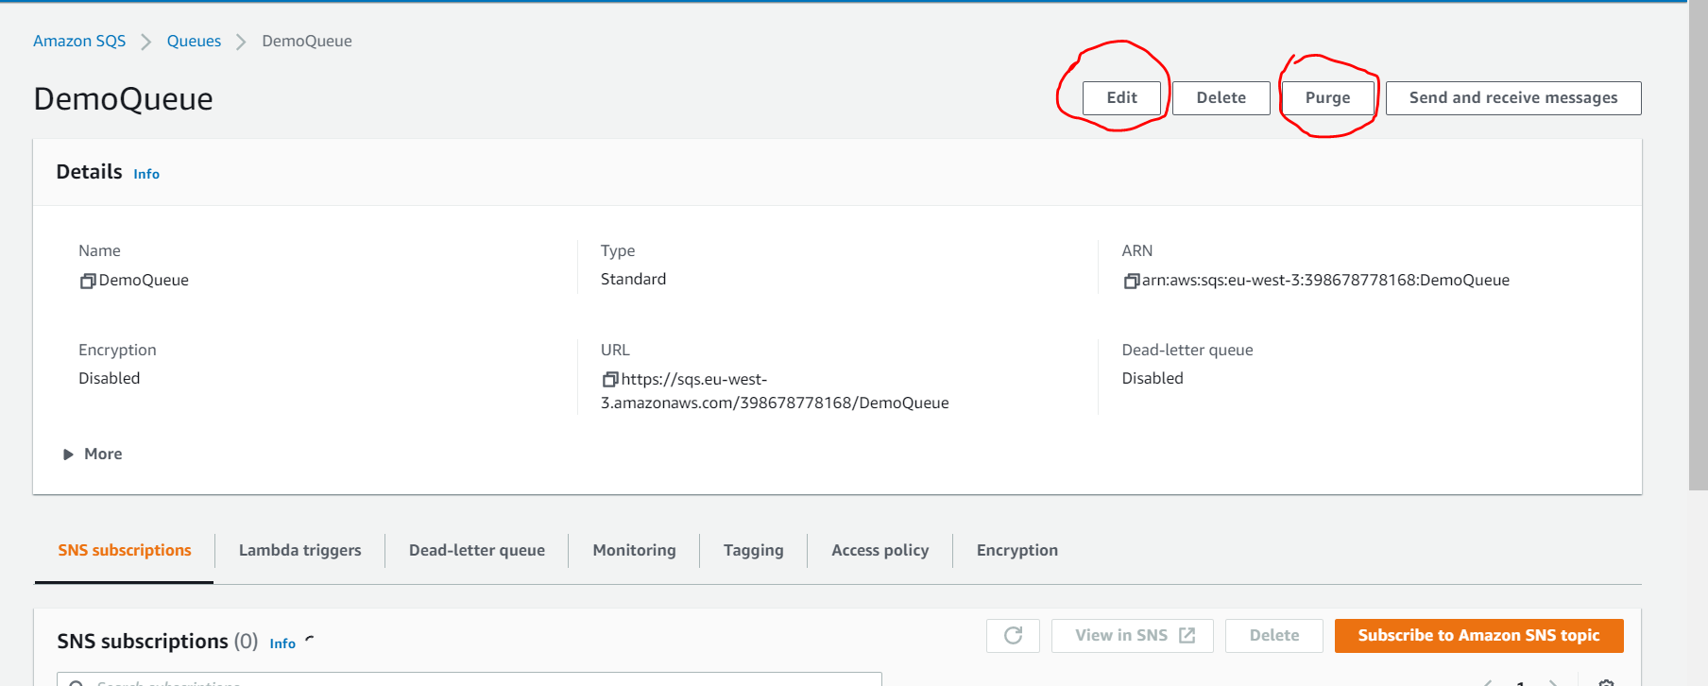

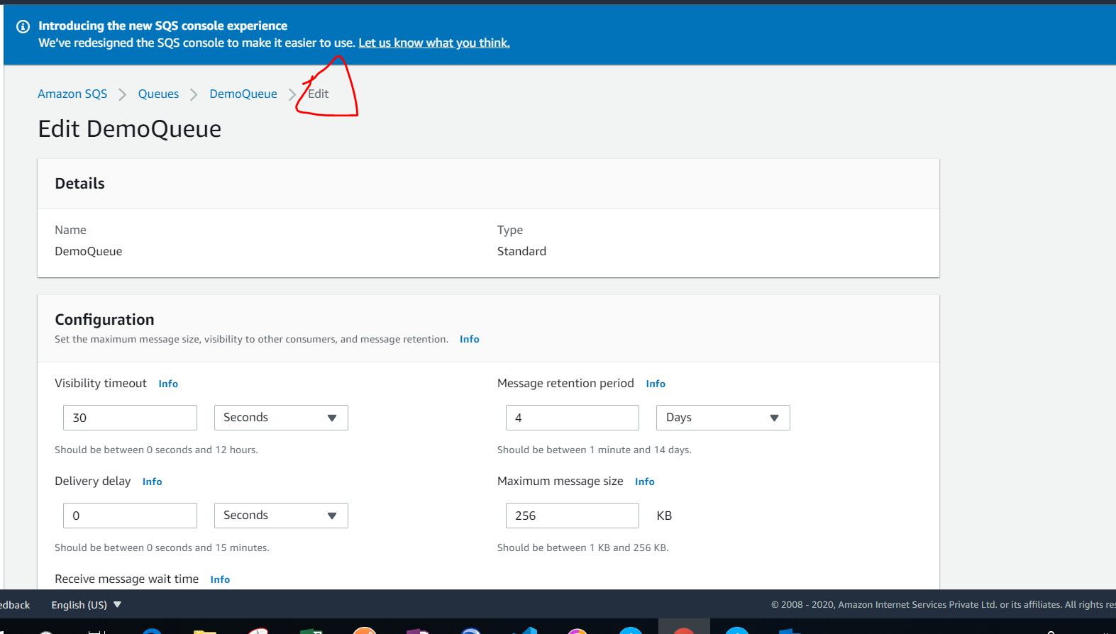

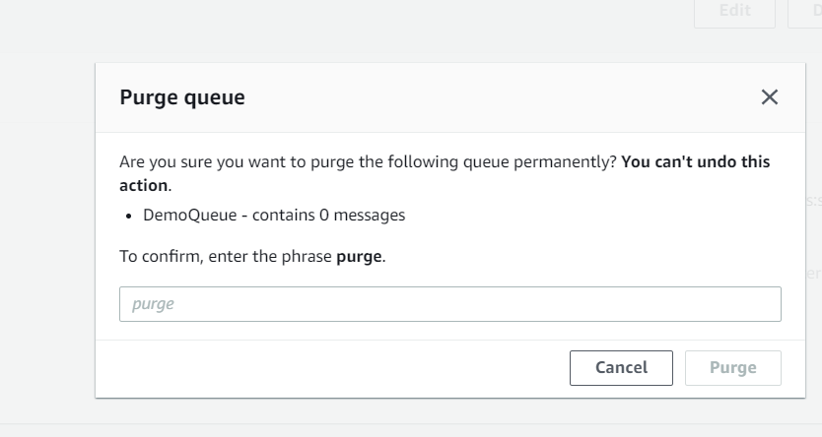

**Other features of queue we can monitor also and access policy ( who can access it)**

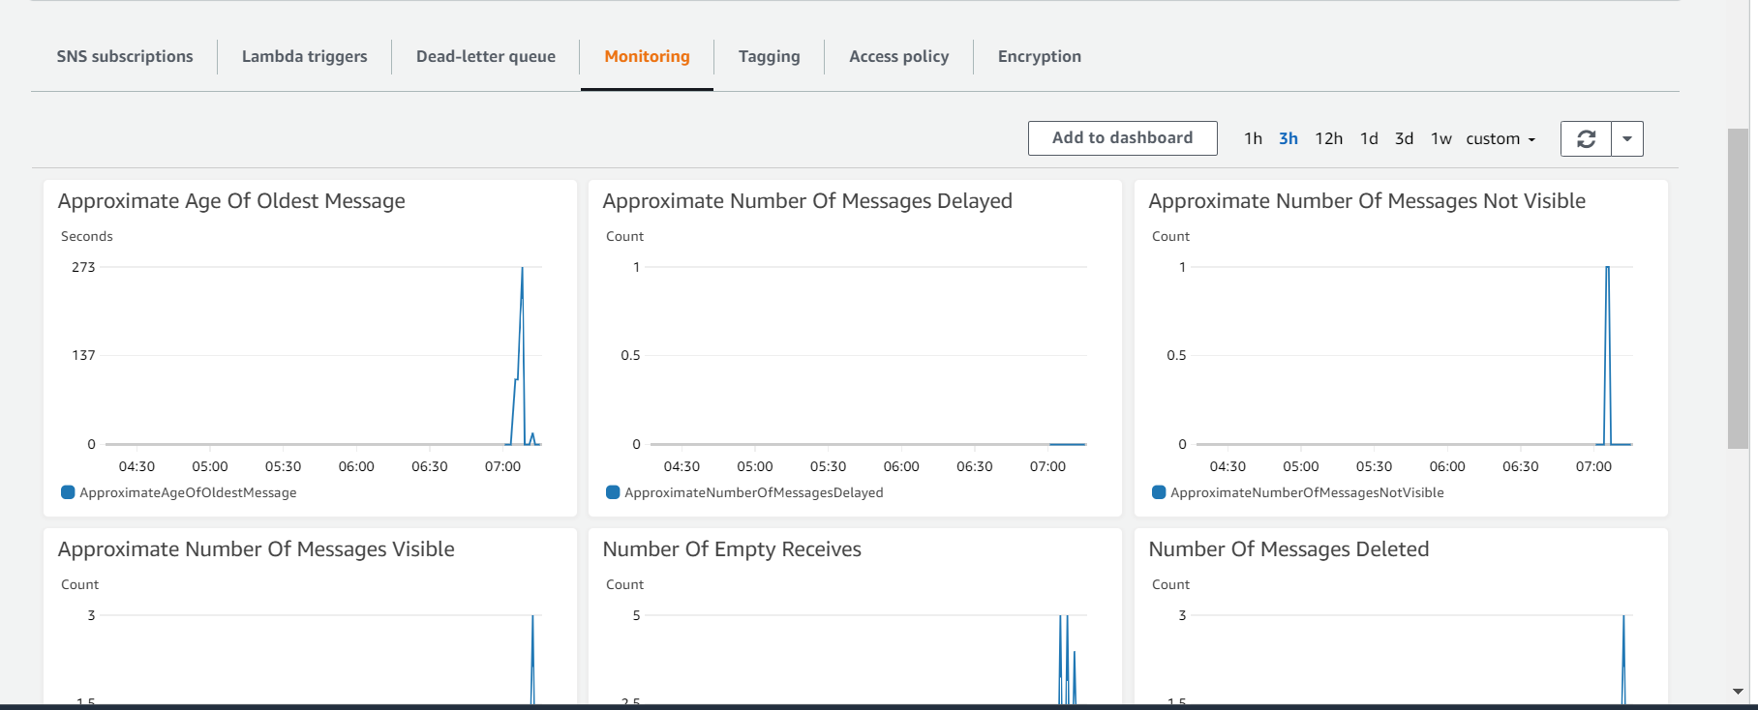

**SQS message visibility Timeout**

**Important concept:**

When message is processed by consumer other consumer cant process it during visibility time period if message is not deleted then after visibility time period consumer can process it

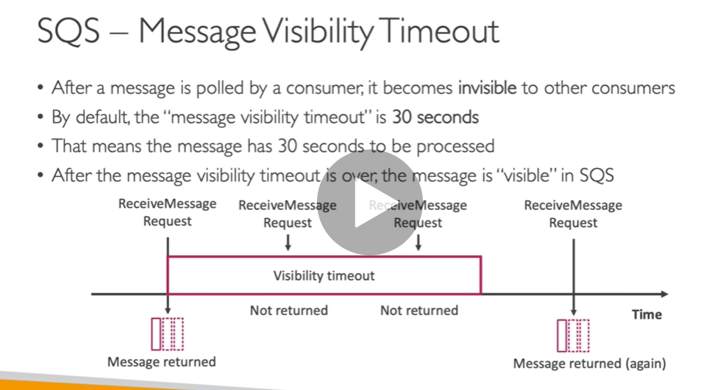

Note **: if a time taking by consumer is more to consume message( not able to process within visibility timeout) then it will call api ChangeMessageVisibility to get more time**

**How we set this MessageVisibilityTimeout**

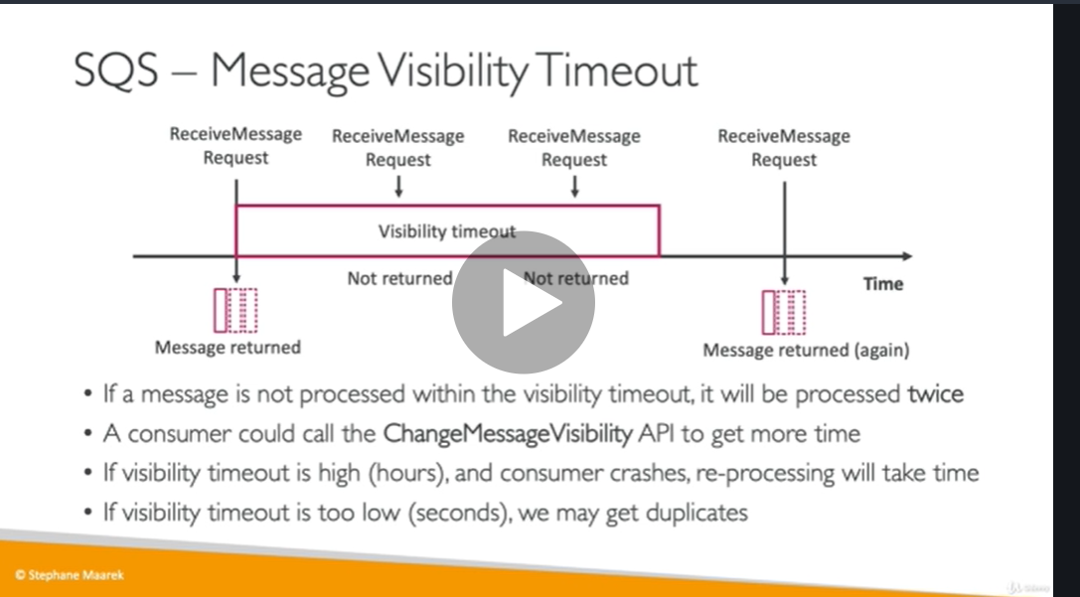

To prevent other consumers from processing the **message** again, Amazon **SQS** sets a **visibility timeout**, a period of time during which Amazon **SQS** prevents other consumers from receiving and processing the **message**. The default **visibility timeout** for a **message** is 30 seconds. The minimum is 0 seconds. The maximum is 12 hours.

Demo

Open two windows send and receive messages

In first window type hello world and poll it default time is 30 second so when u from second consumer it will not get but if u stop polling then message is back in queue and second consumer will get message

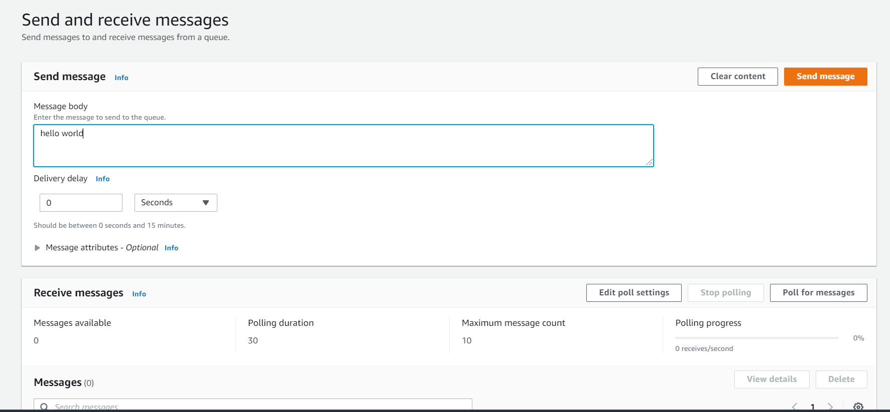

In first consumer polling time going on

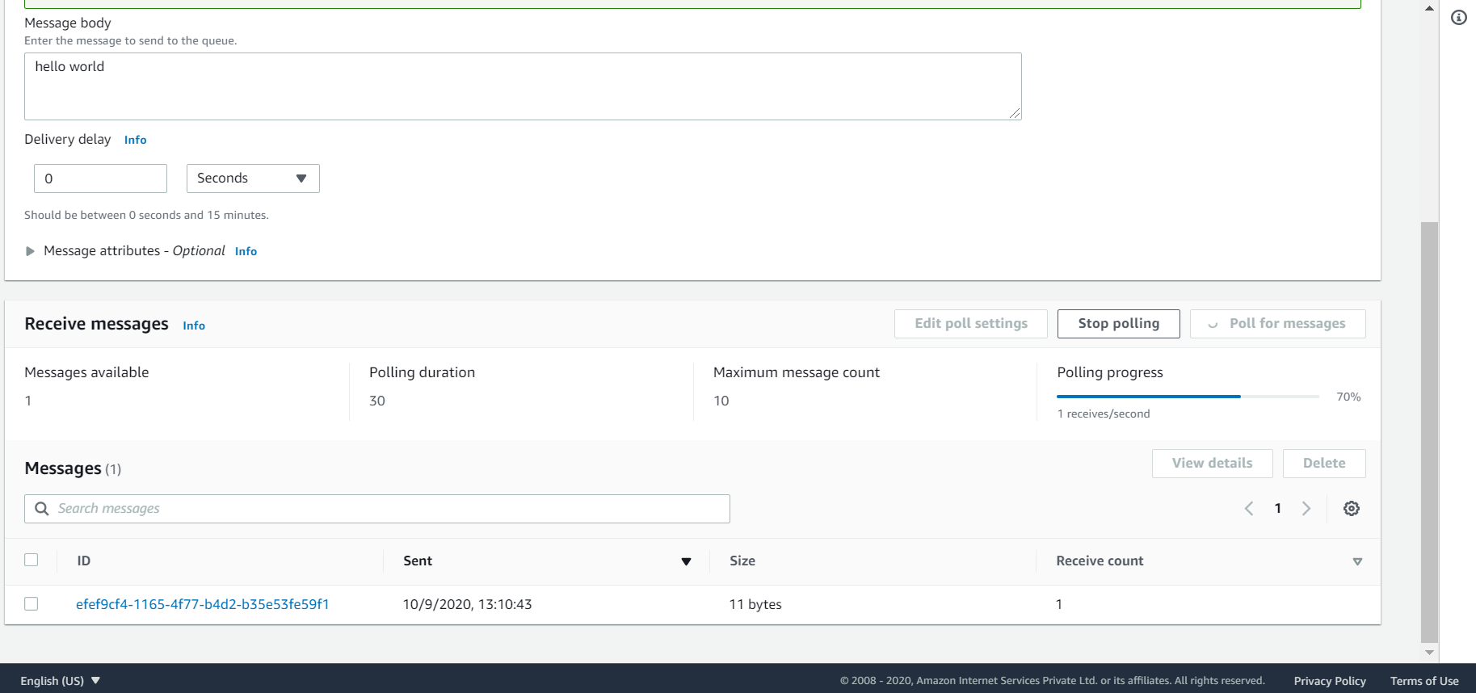

Once default time completed message will appear to second consumer since message is back to queue

Note : **if consumer need more time to process message we can increase visibility timeout time**

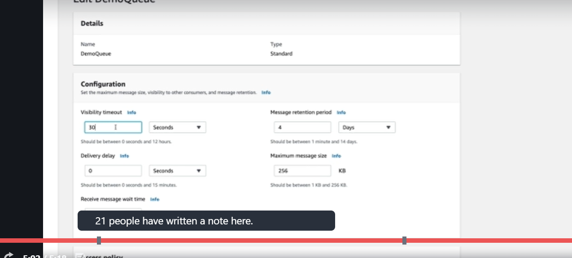

**Note : we need to read message in visibility time period only**

**SQS Dead Letter Queues**

**If a message is processed so many time not successfully then t will send to dead letter queue**

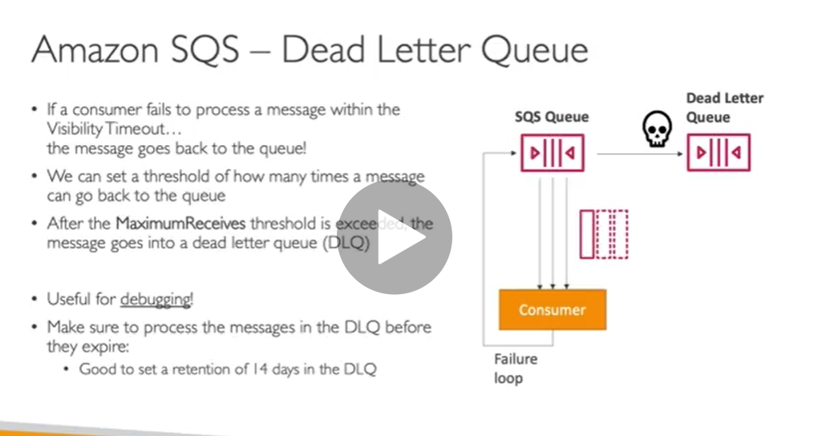

**DEMO:**

**First create DLQ and give retention to 14 days**

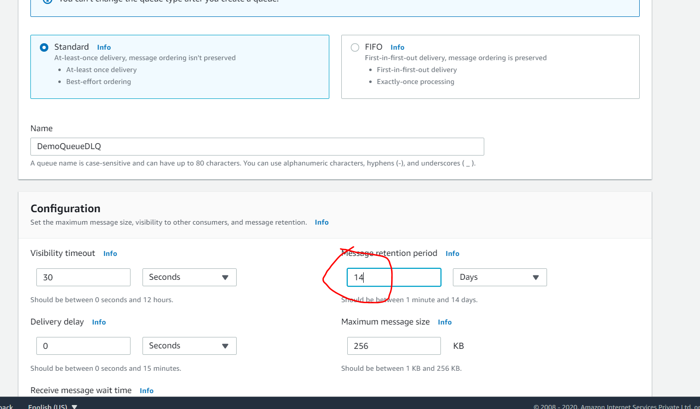

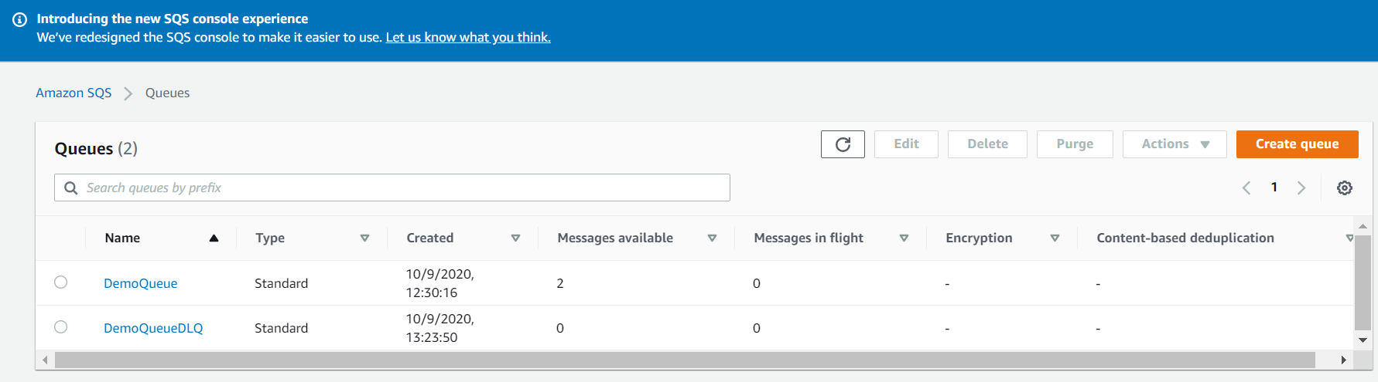

**Link DLQ from demo queue**

**Edit demoqueue**

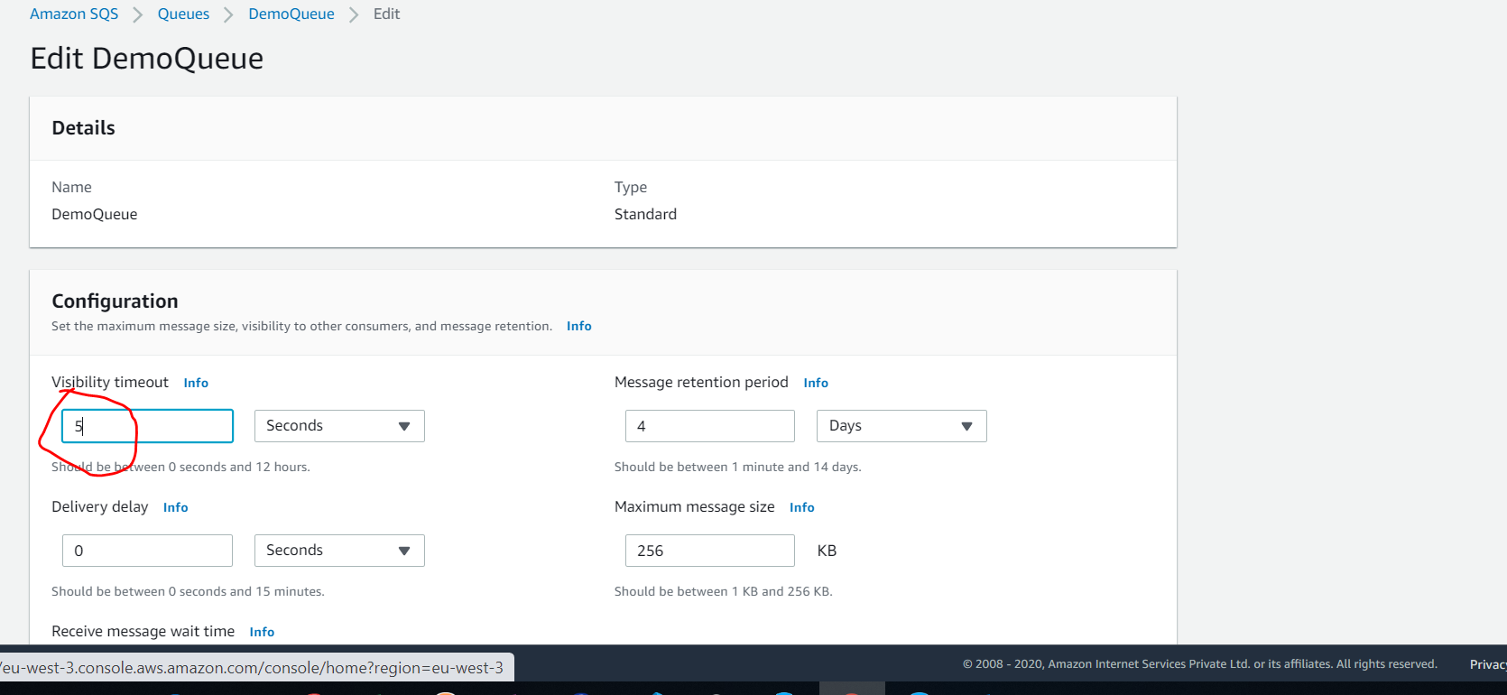

**Click on enabled**

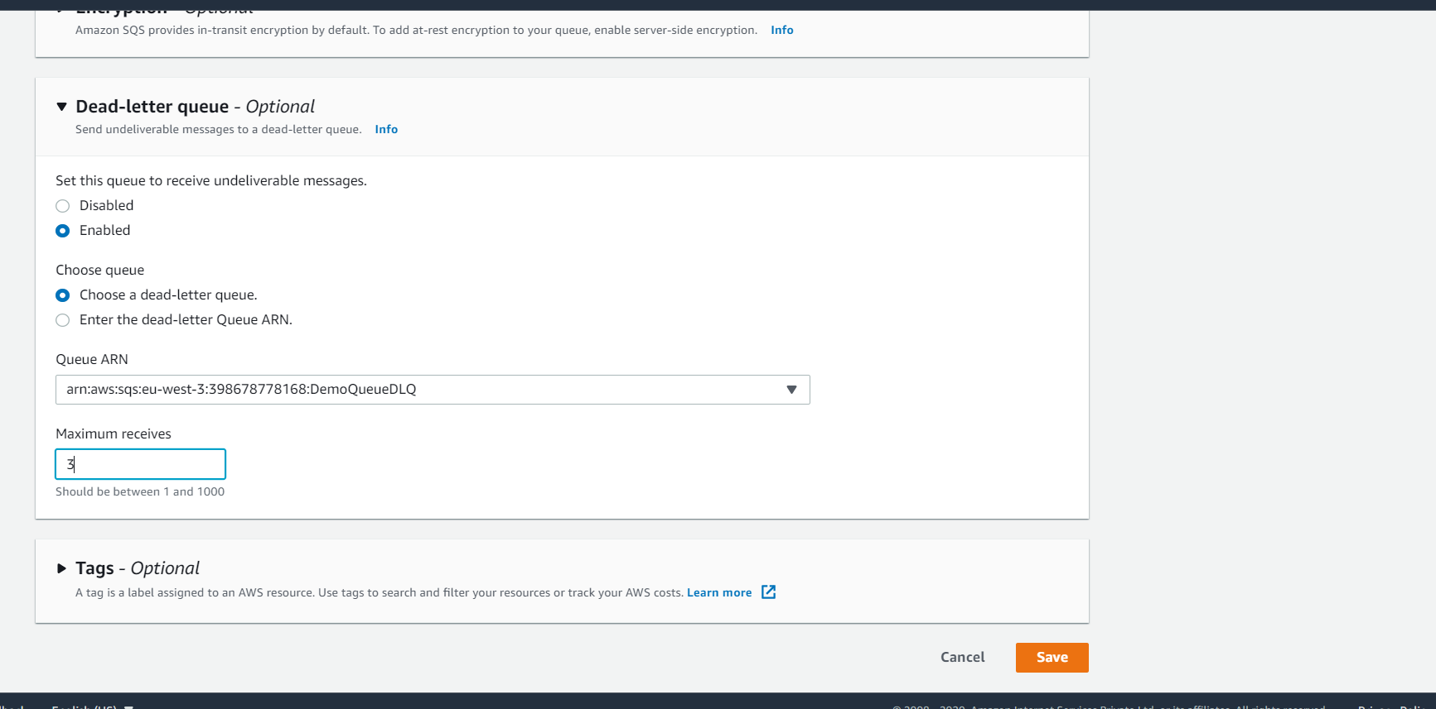

**Open demo queue and dlq( send and receive message)**

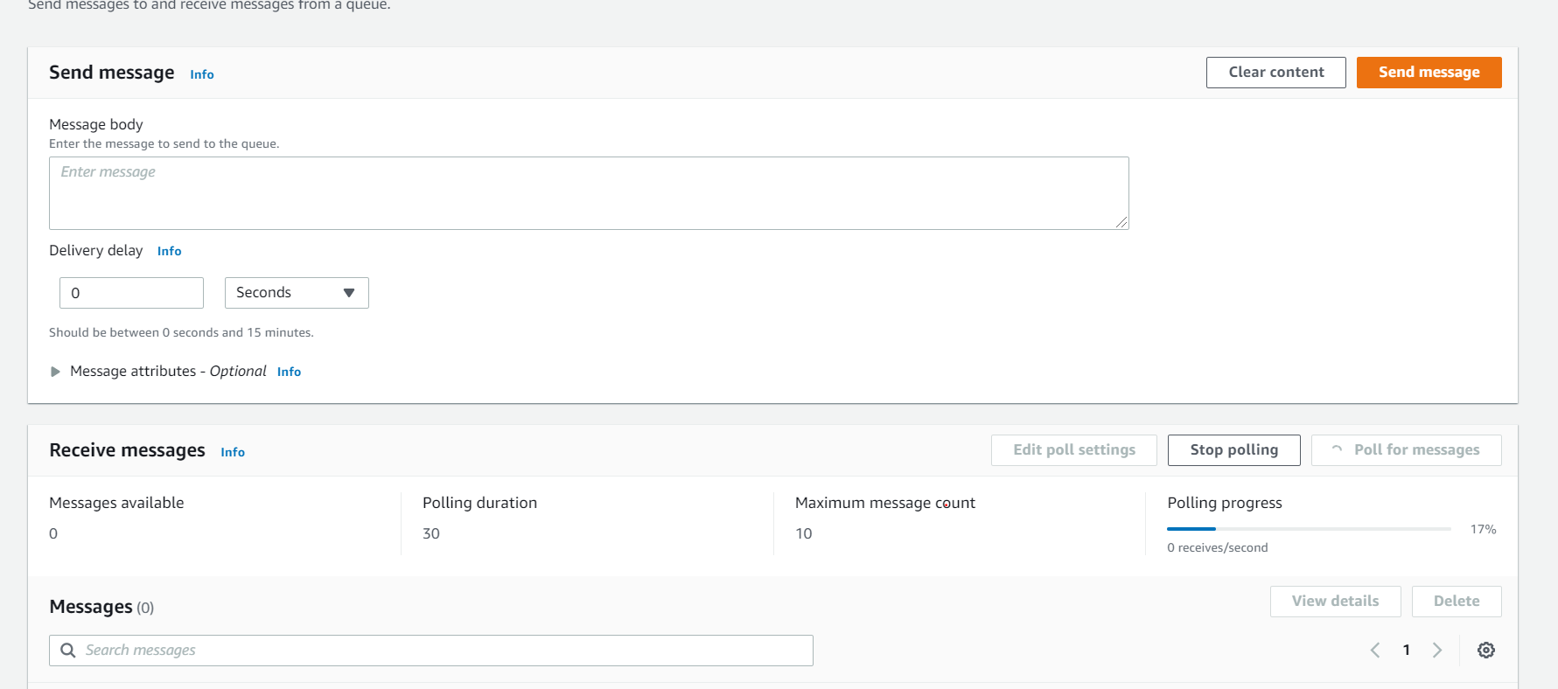

**Click on poll for message in dlq**

**If message is not processed then it will go to dlq**

**Amazon SQS - Delay Queue**

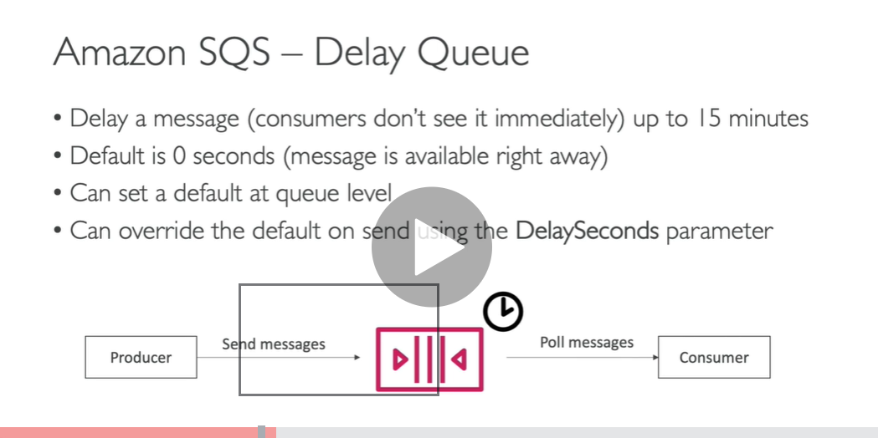

**Demo**

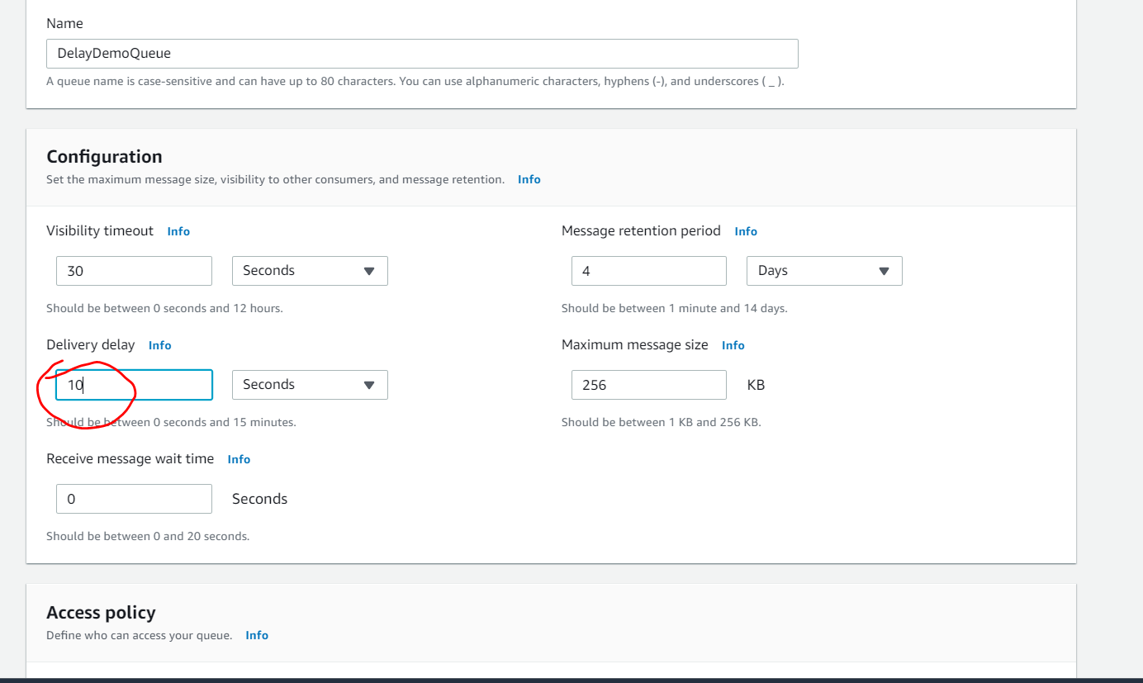

**Consumer poll message and send message then consumer will get message after 10 second**

**SQS Certified Developer**

**Amazon SQS long polling is a way to retrieve messages from your Amazon SQS queues. While the regular short polling returns immediately, even if the message queue being polled is empty, long polling doesn't return a response until a message arrives in the message queue, or the long poll times out.**

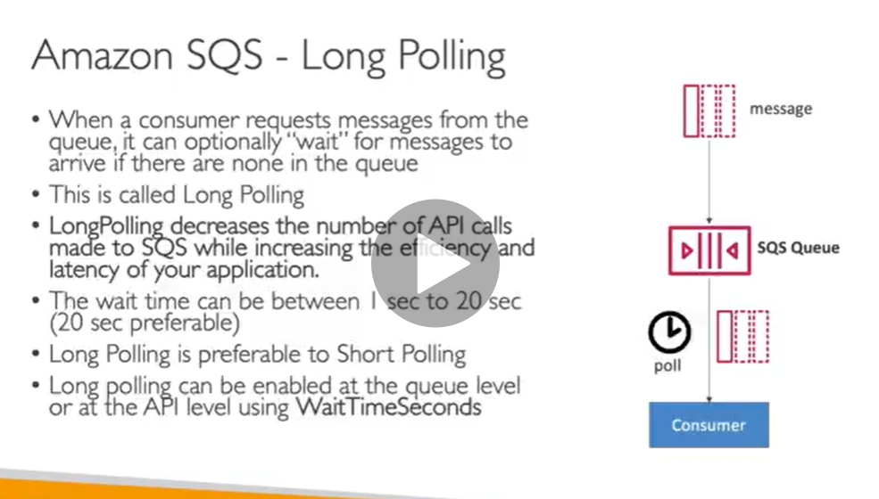

**imp :- SQS will tell to consumer hey go and retrieve bigger message from s3**

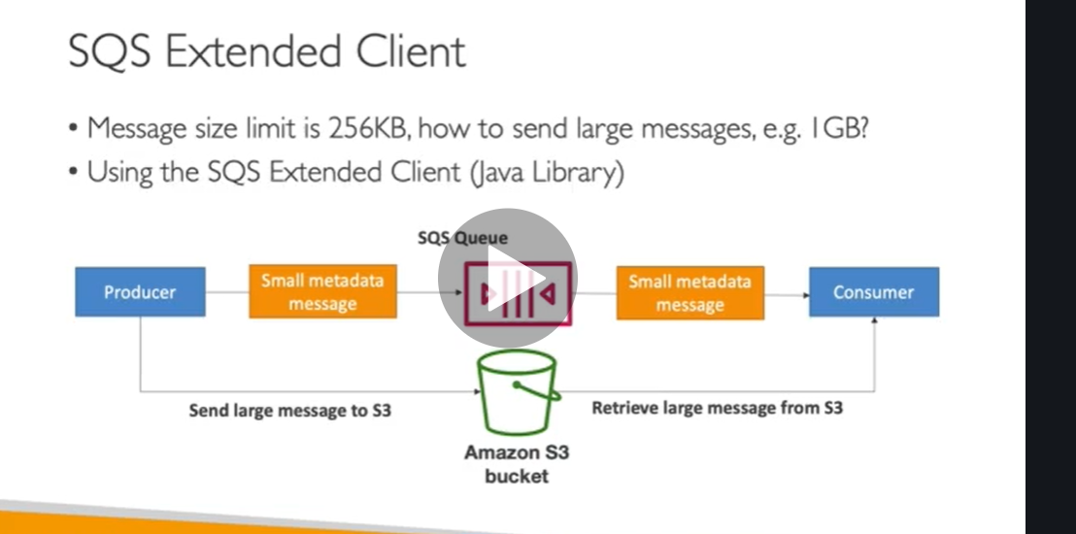

**Example video file : send pointer to video file**

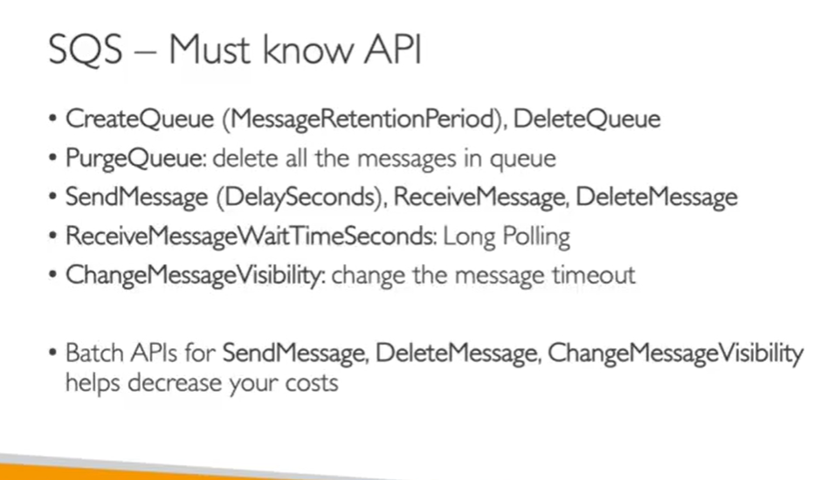

**Receive message wait time =0 ( short polling)**

**Receive message wait time not 0 means**

**U should wait this much of time if sqs is empty**

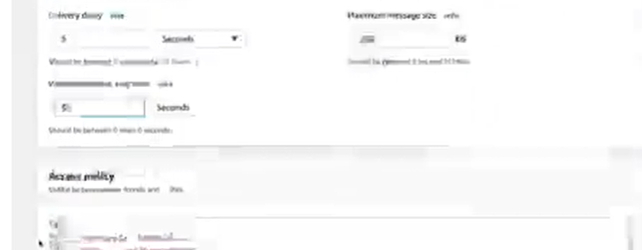

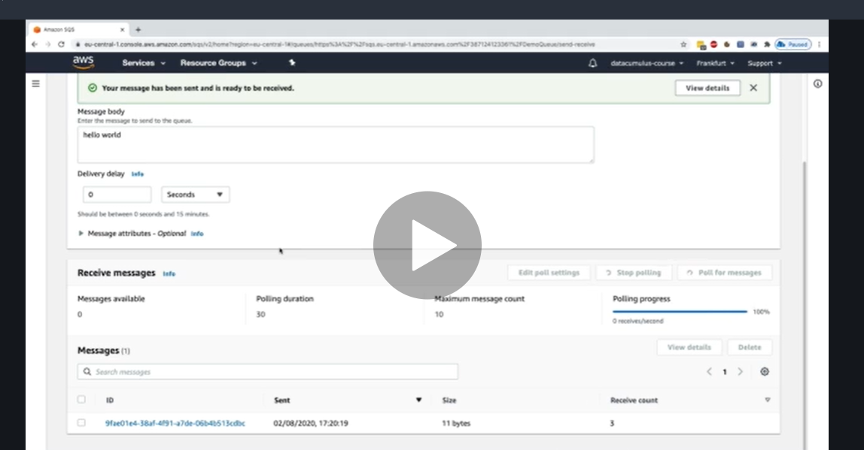

**SQS Fifo Queue**

**Note : it remove duplicates**

**Maintain ordering of message**

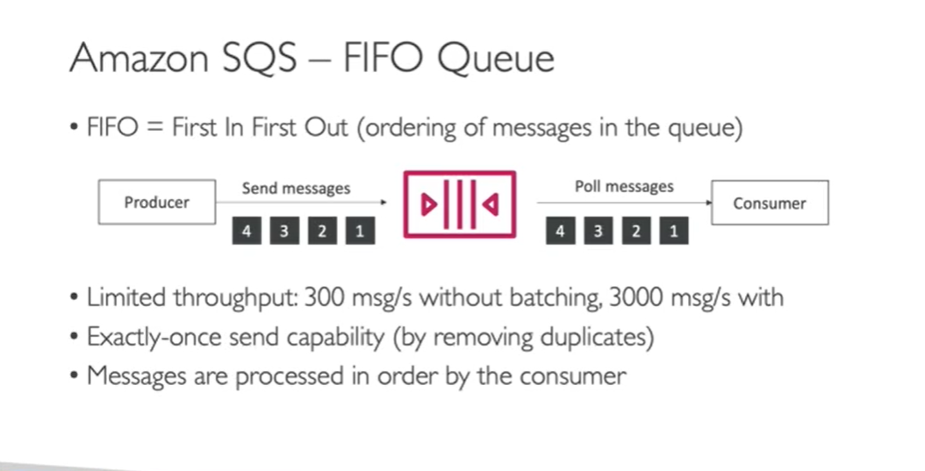

**Demo**

**We must give name by ending .fifo**

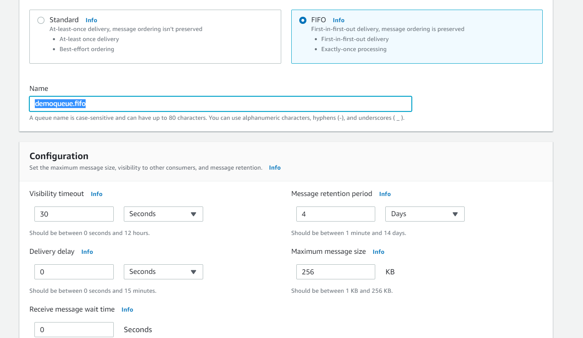

**To enabled duplication of messages**

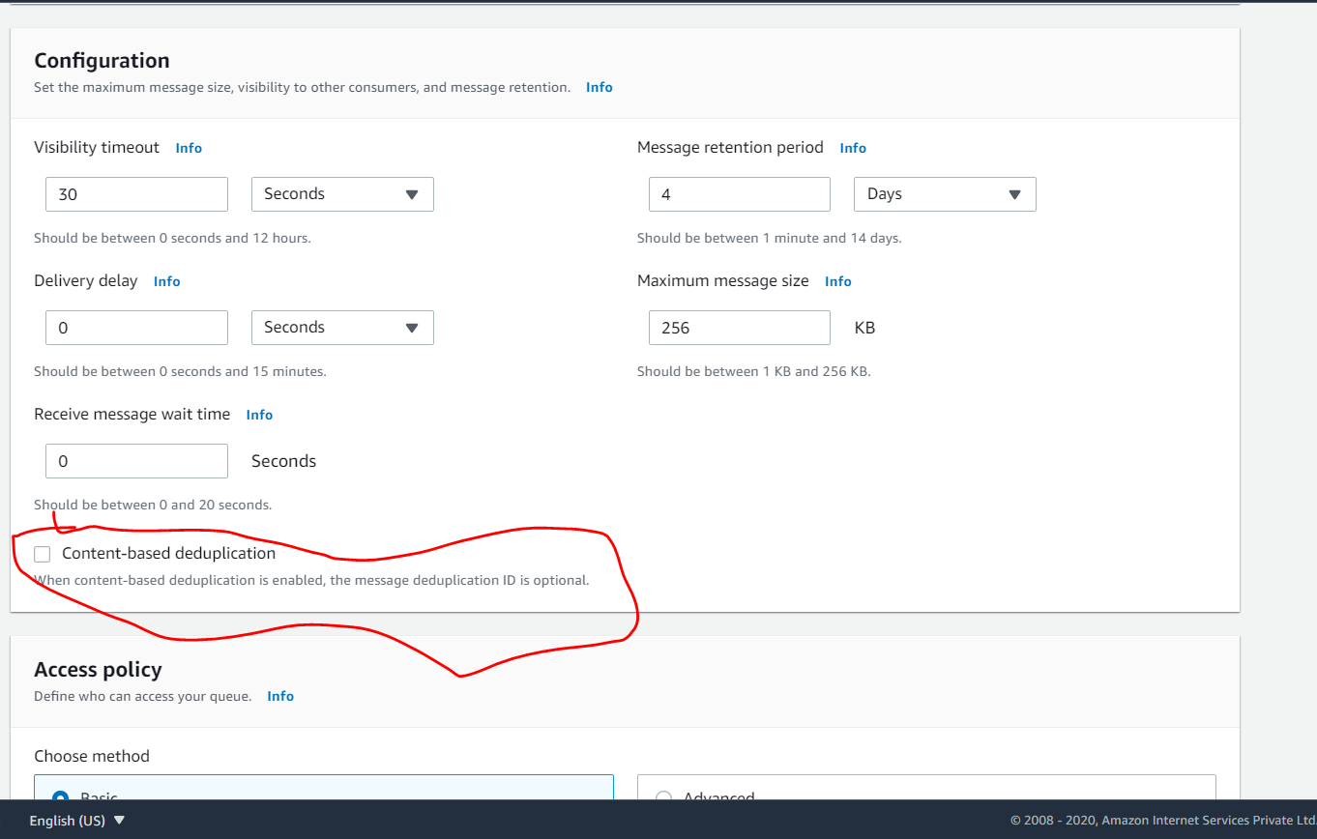

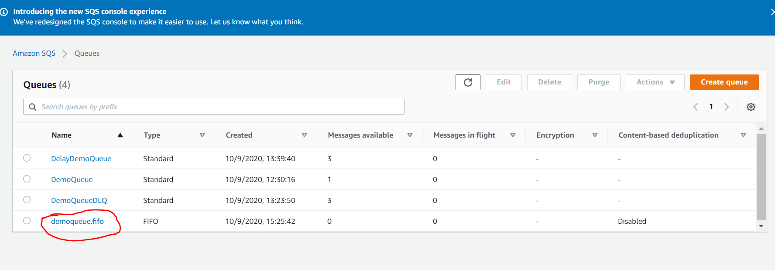

// like this send some messages with id change

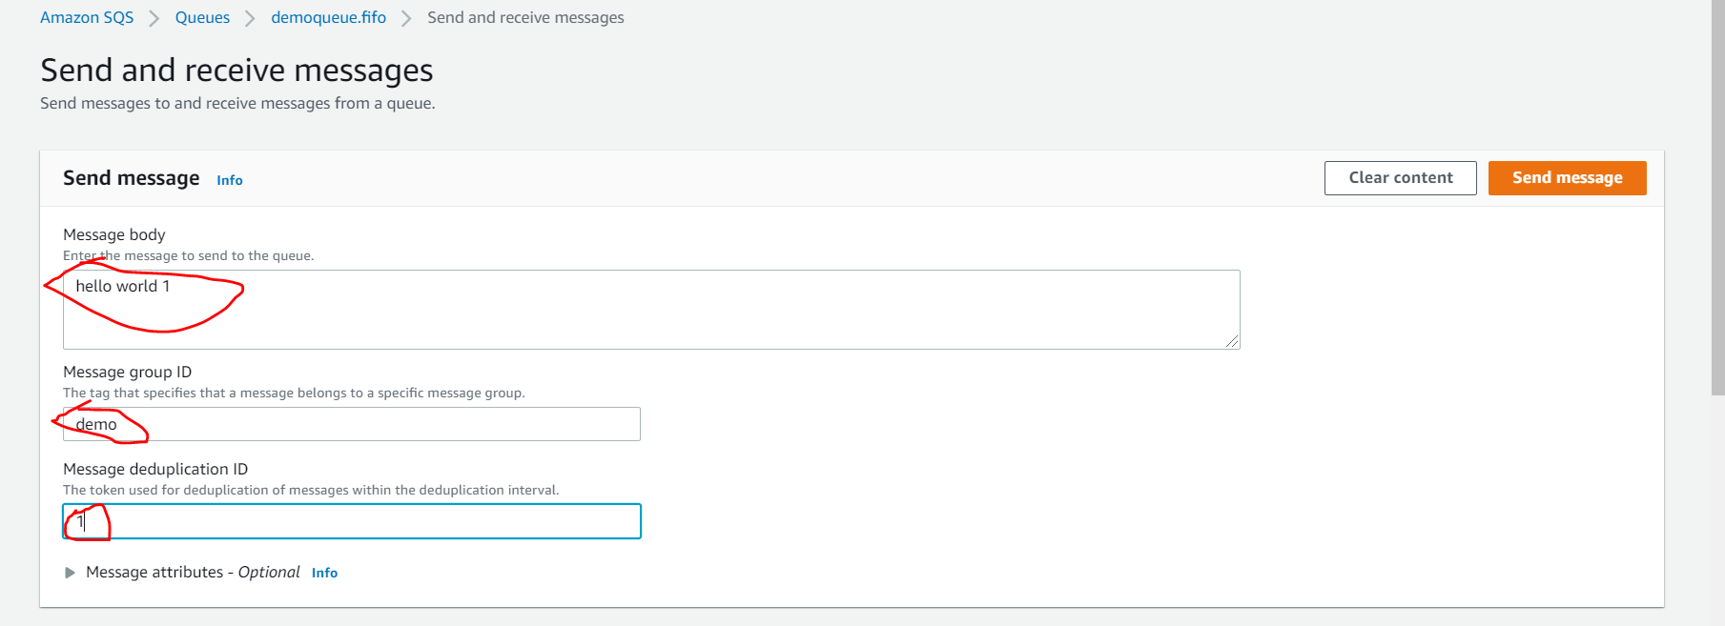

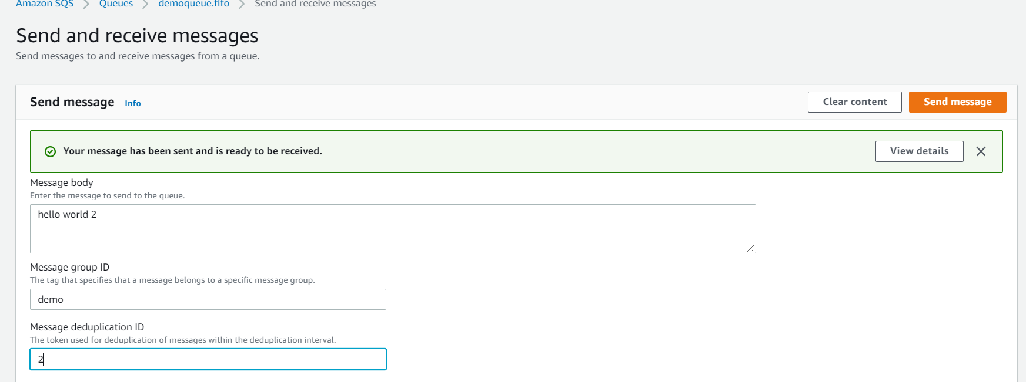

**once u poll message will come in order**

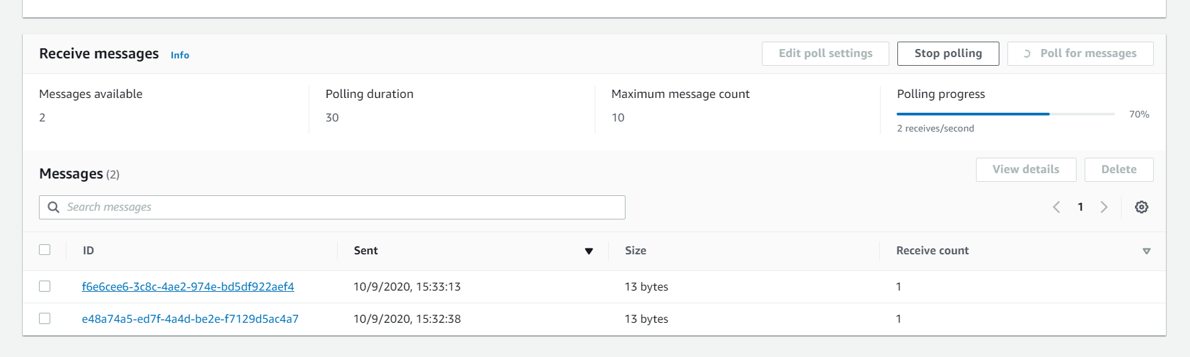

**SQS Fifo Queue Advanced**

**Deduplication of message : if we send same message twice to SQS within 5 minutes the second message will refuse.**

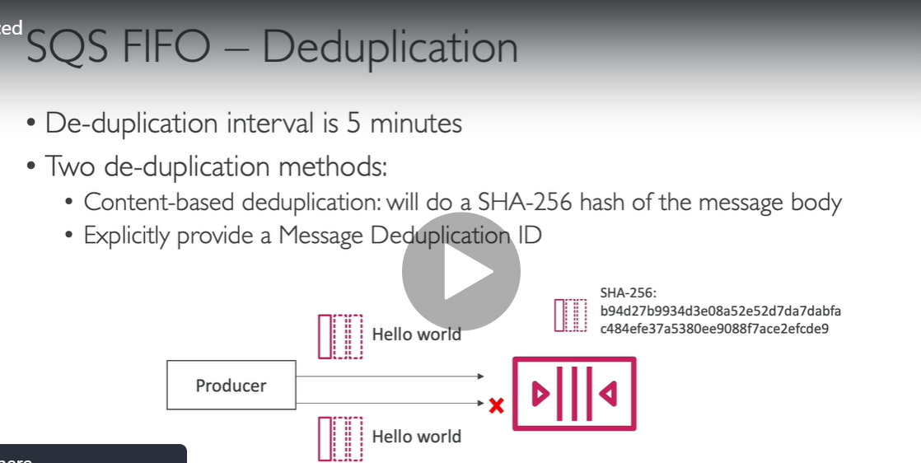

**Note :**

**Want ordering of message for a specific customer it not all**

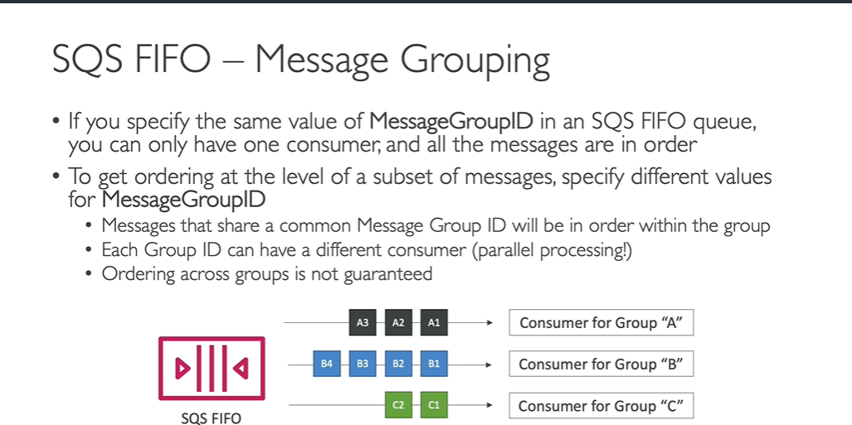

**Content based deduplication demo**

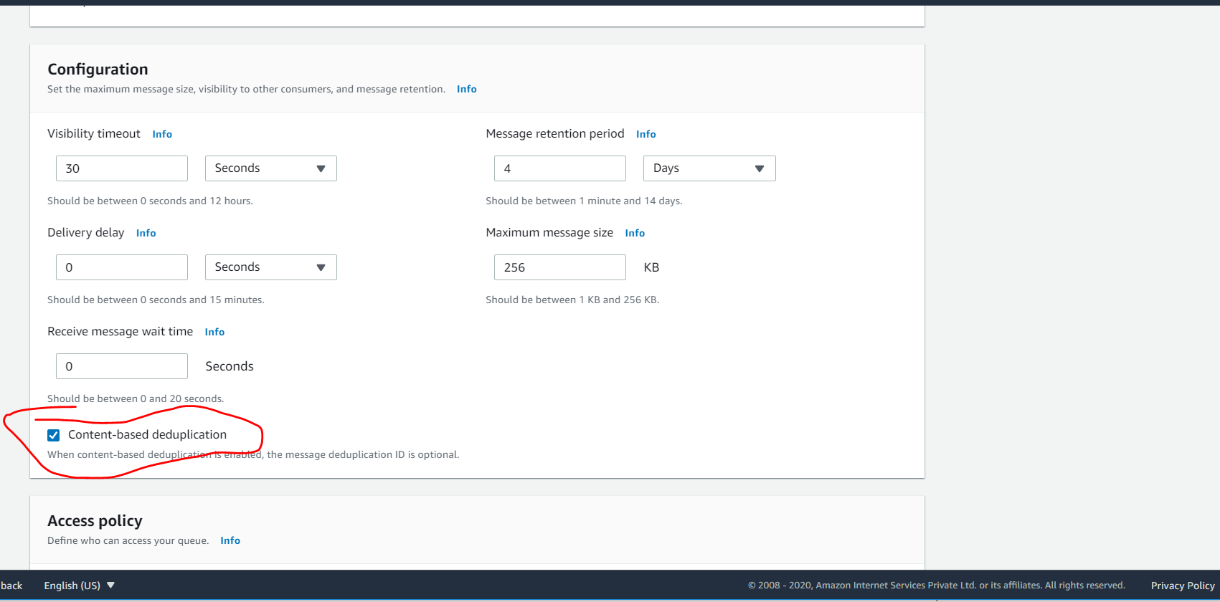

**If we send same message it will go only once**

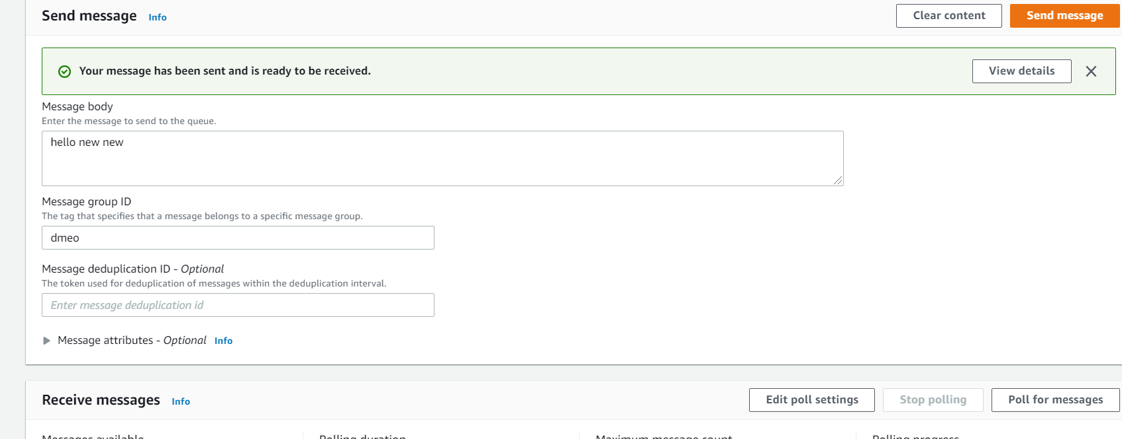

**Amazon SNS (Simple Notification Service)Overview**

**Requirement : want to send one message to many receiver**

Amazon Simple **Notification** Service (**SNS**) is a **notification** service provided as part of Amazon Web Services since 2010. ... **SNS** can also deliver **messages** by SMS to 200+ countries. **SNS** uses the publish/subscribe model for push delivery of **messages**.

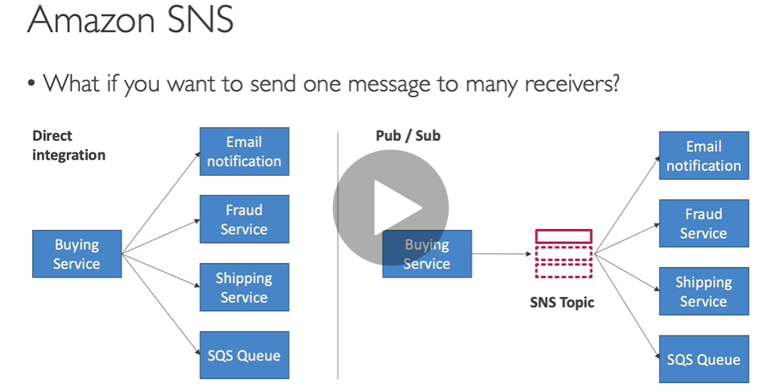

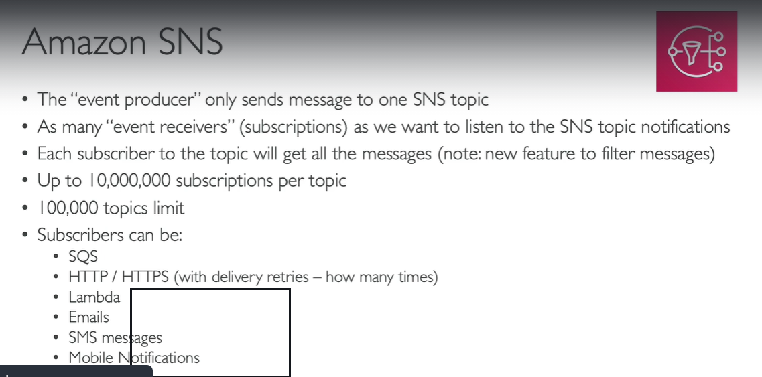

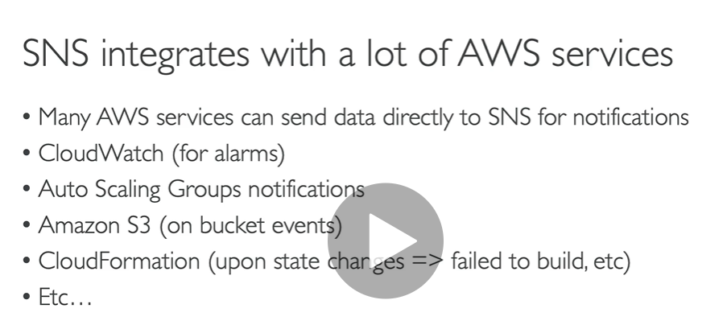

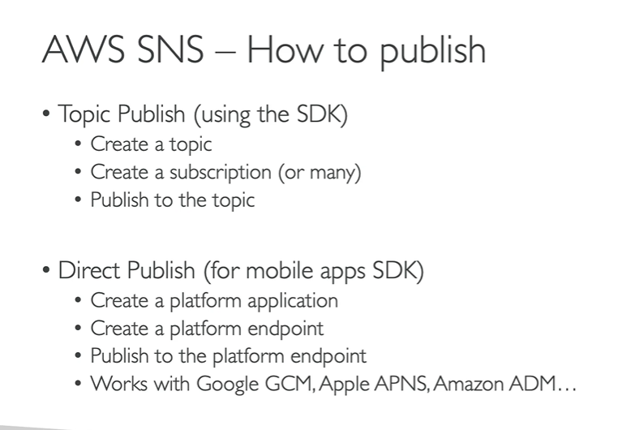

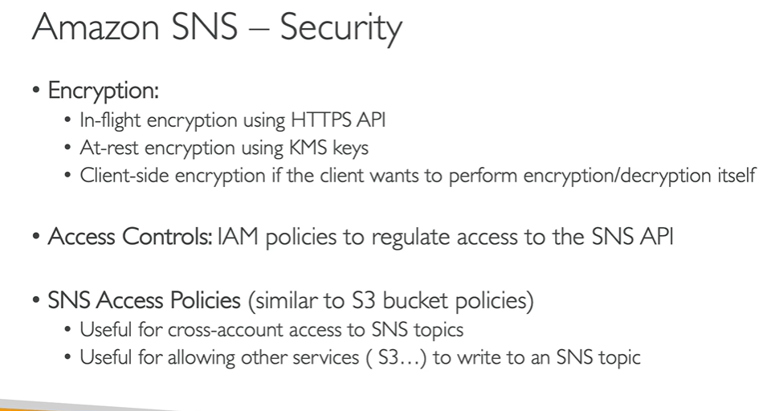

**SNS Hands on**

**Search SNS/ create first topic**

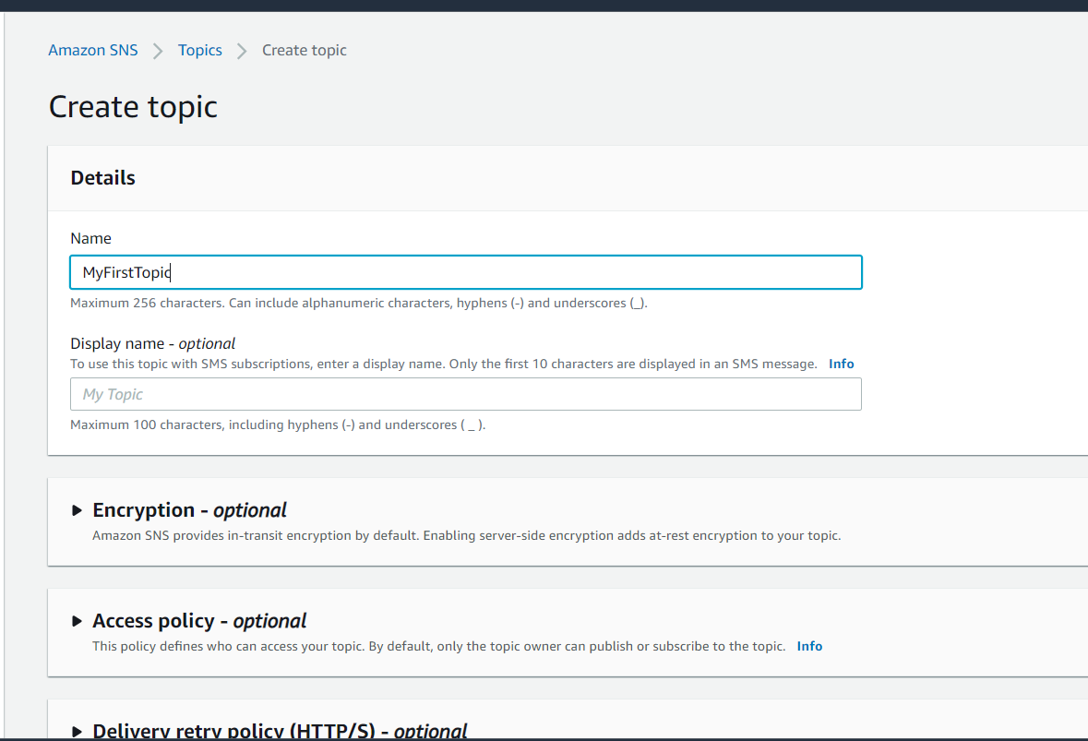

**Click next**

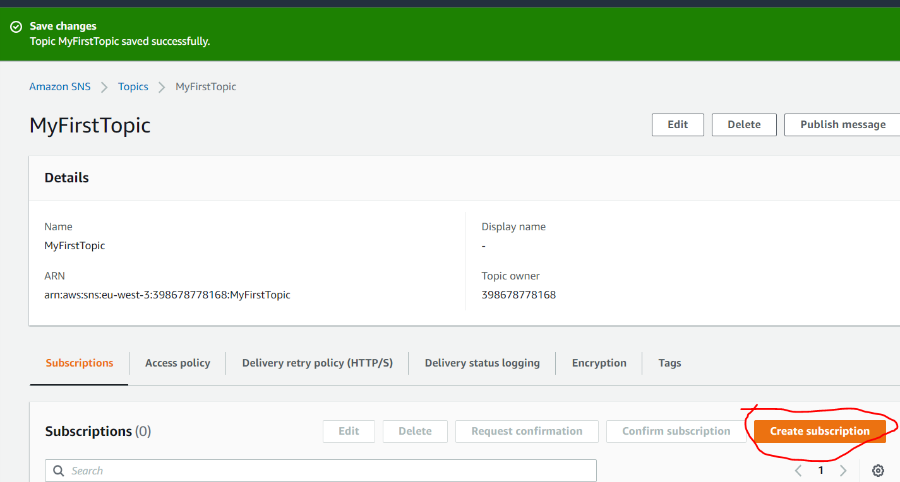

**Click create subscription**

**Remember these protocols**

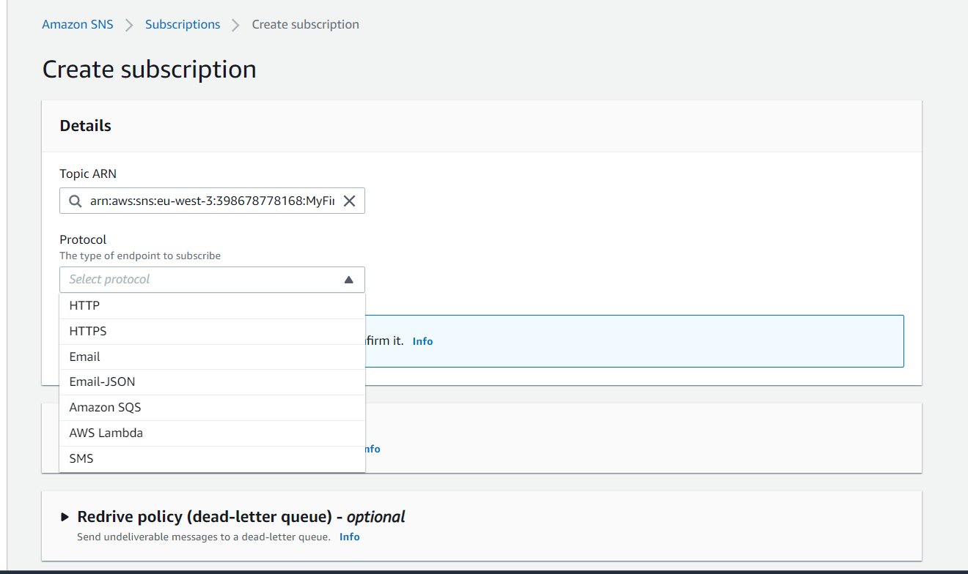

**Mailinator : public inbox**

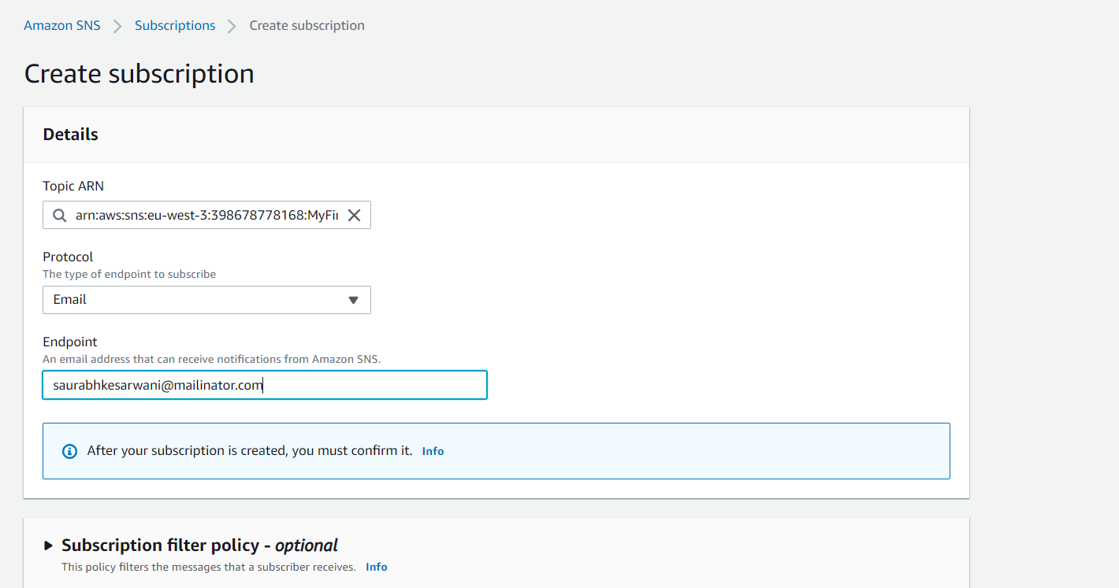

**Click create subscription**

**Note : it showing pending confirmation go to mail box and subscribe it**

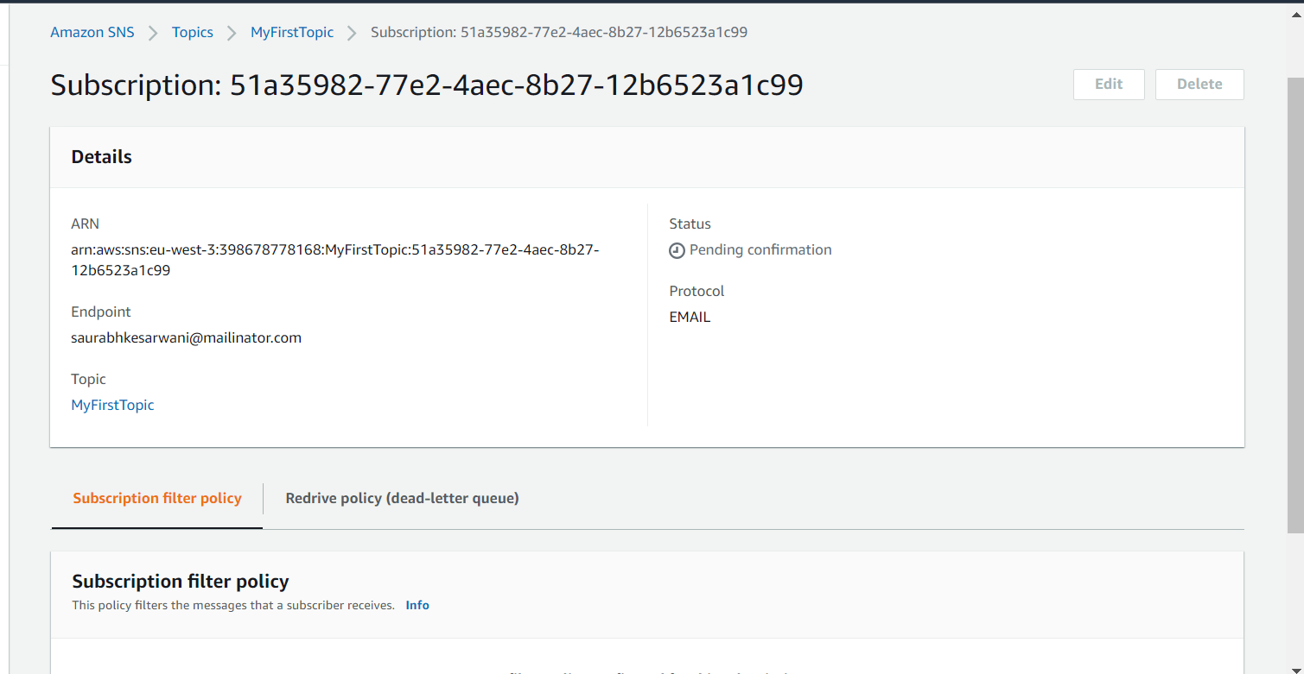

**Then that email is subscribe to topic**

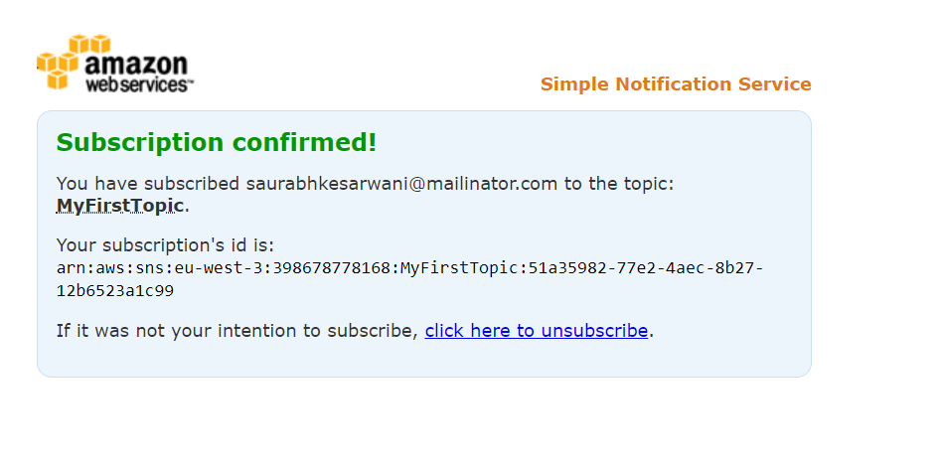

**Now status is confirmed**

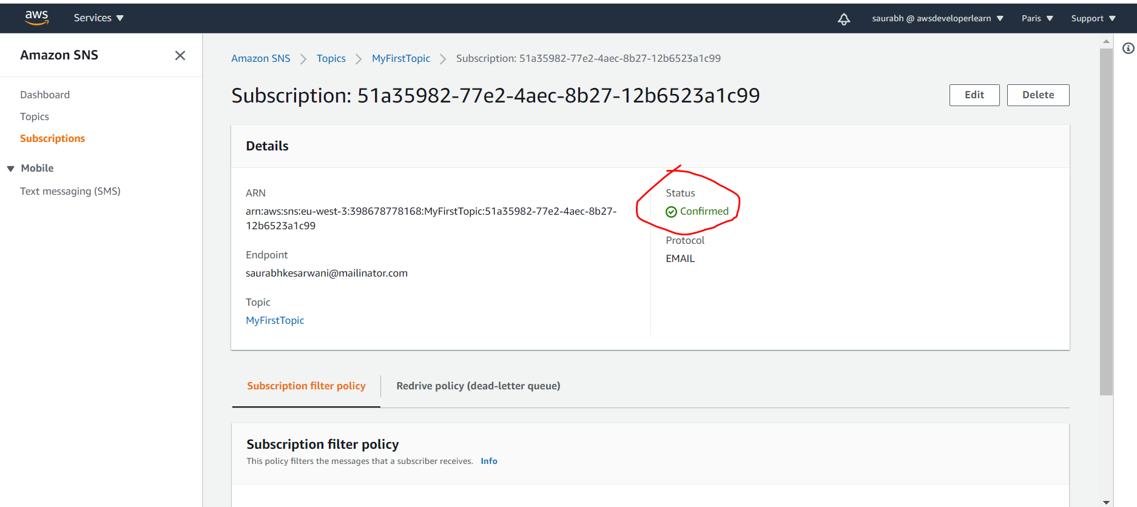

**Back to topic we can create more subscription but as of now one is fine now click on publish message**

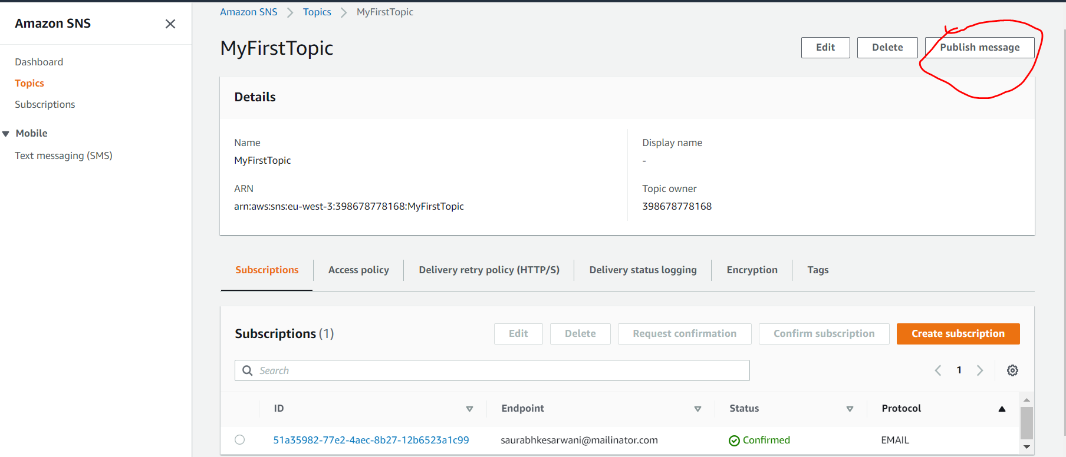

**Publish message then check inbox**

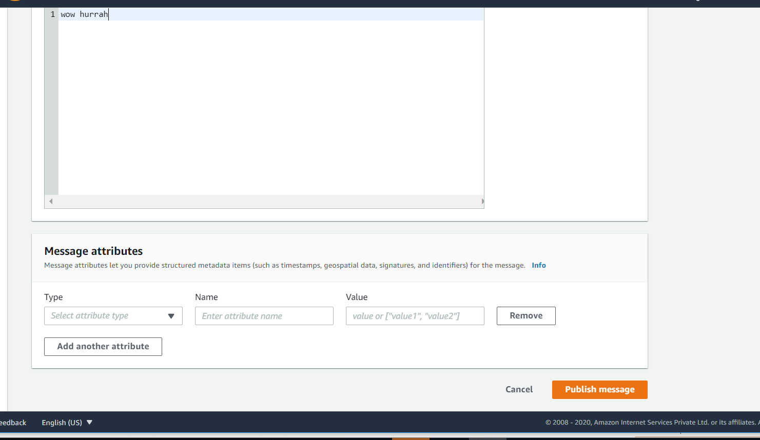

**And messages is delivered to inbox**

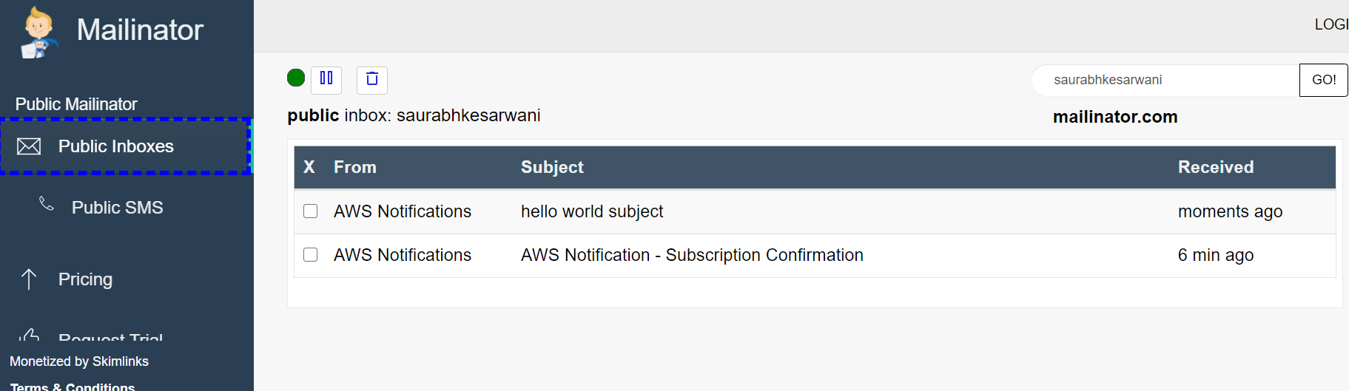

**SNS+SQS : Fan Out**

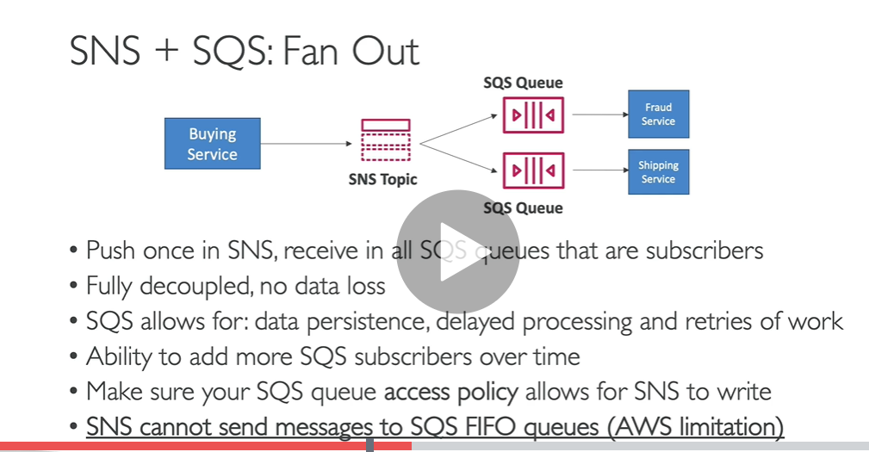

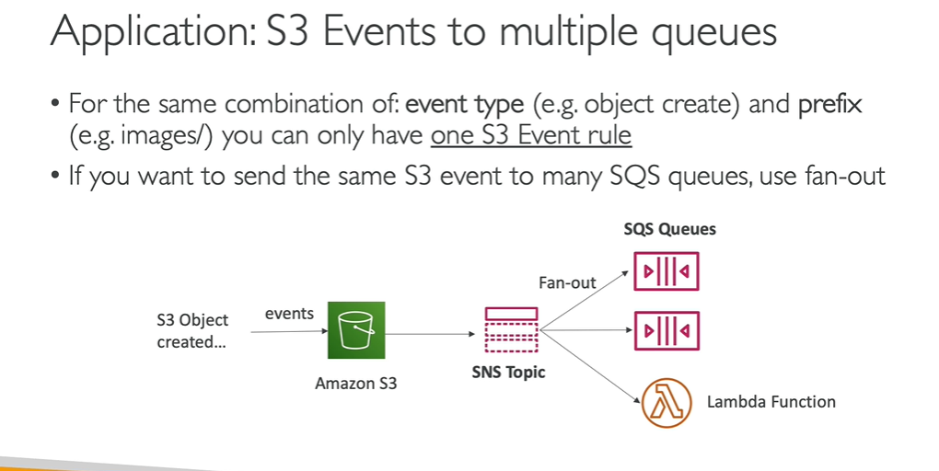

**AWS Kinesis Overview**

**Is use for computation of real time data arrived through stream**

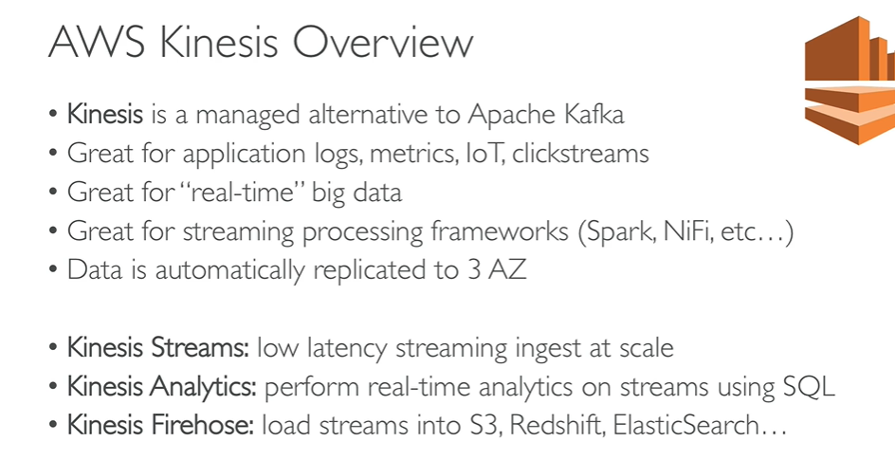

**Note:**

**Data produces into kinesis stream and kinesis analytic want to processing the data( computation in real time data) and store data in kinesis firehouse(s3,database)**

**Amazon kinesis in the middle that allow to store big data in database**

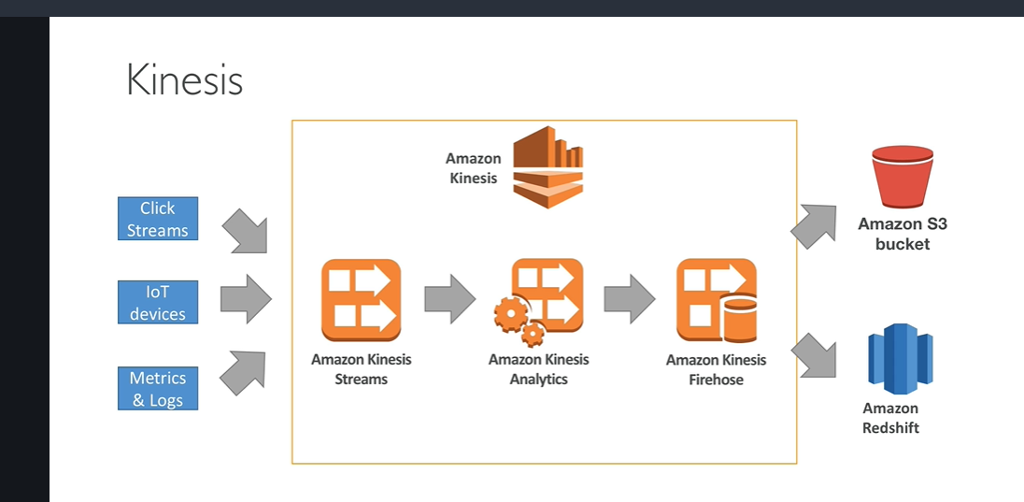

**Note :**

**If we want more throughput we need to increase higher number of shard**

**Difference between sqs and kinesis**

**In sqs : once data is consumed data is gone but while in kinesis data is still there and it will expire after sometime**

**In sqs no order but in kinesis record are going to be in order per shards**

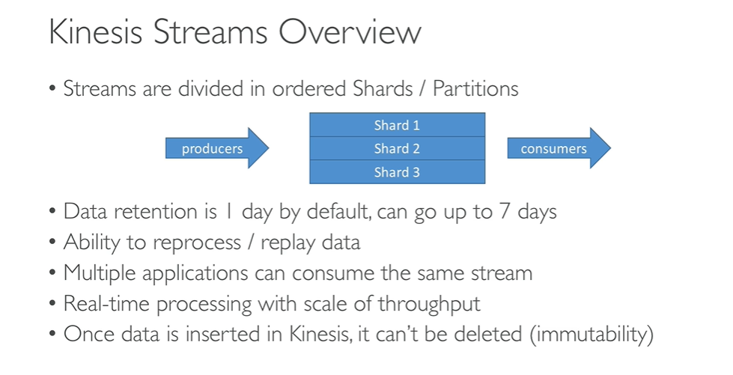

Resharding : througput increases more and we increase shard while someday throughput decreases then merging of shard occur( shard decrease)\

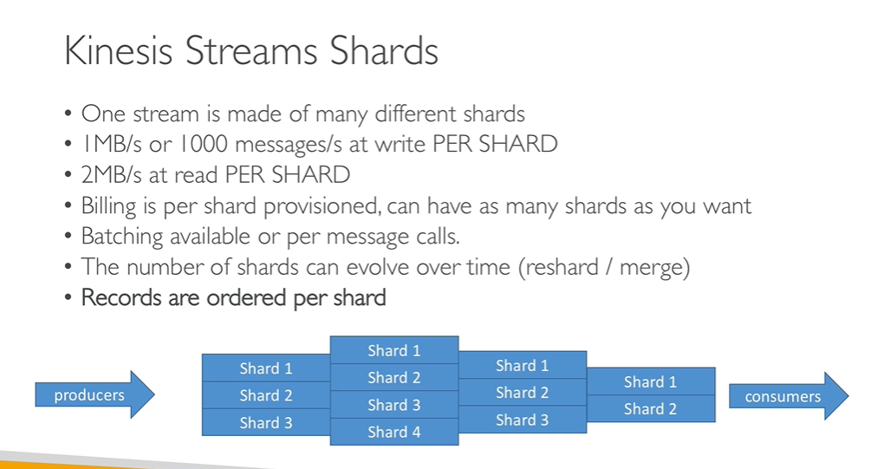

Note : we should stop hot partition:

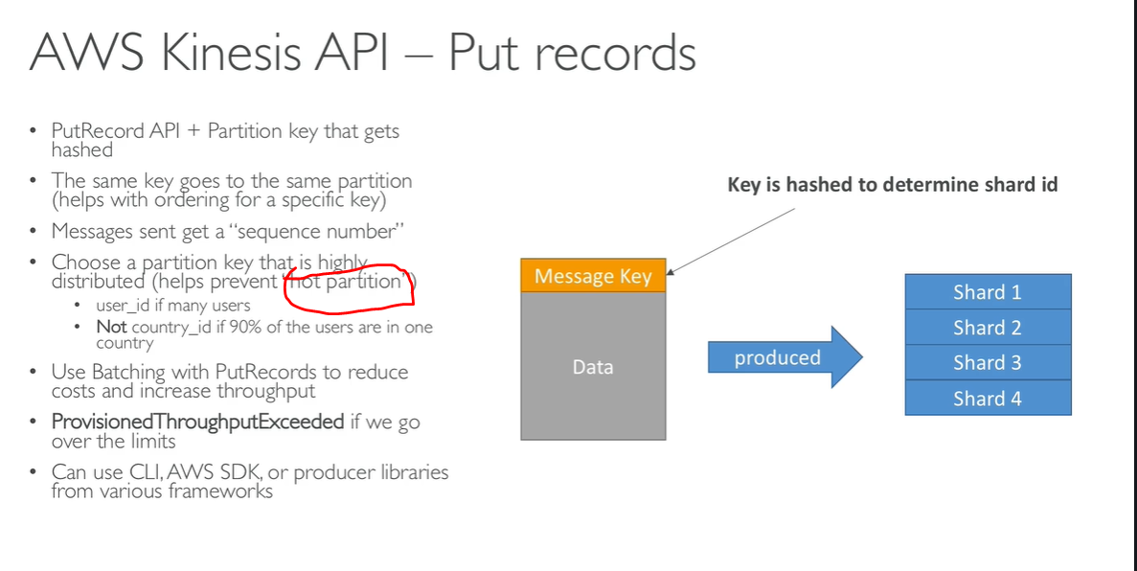

Hot partition : message are going in same shard and it will be overloadeds

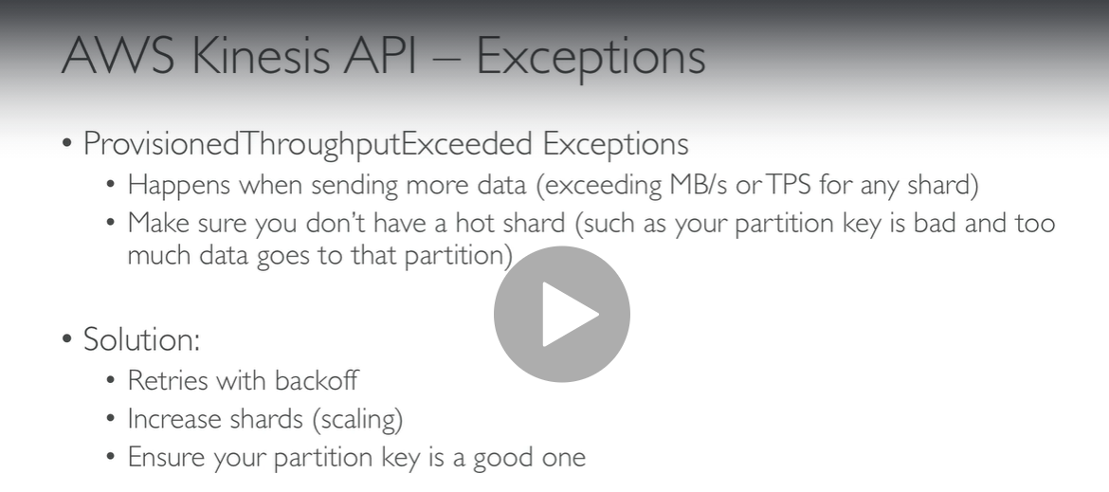

**KCL ( Kinesis Client Library)**: use to consume message from kinesis efficiently

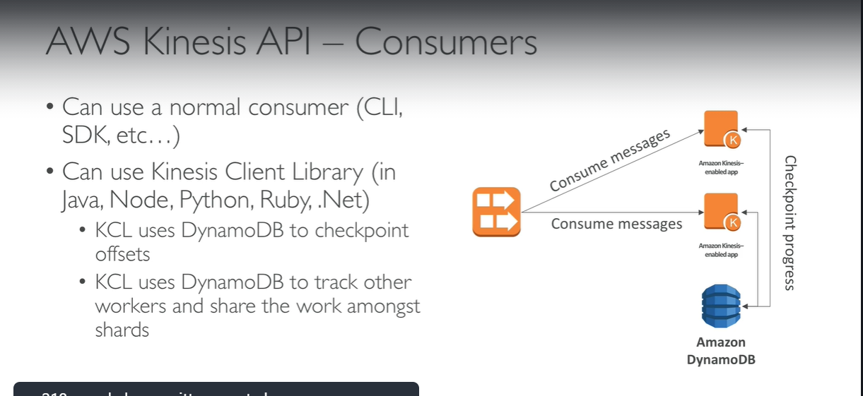

AWS Kinesis hands on ( it is not free paid one)

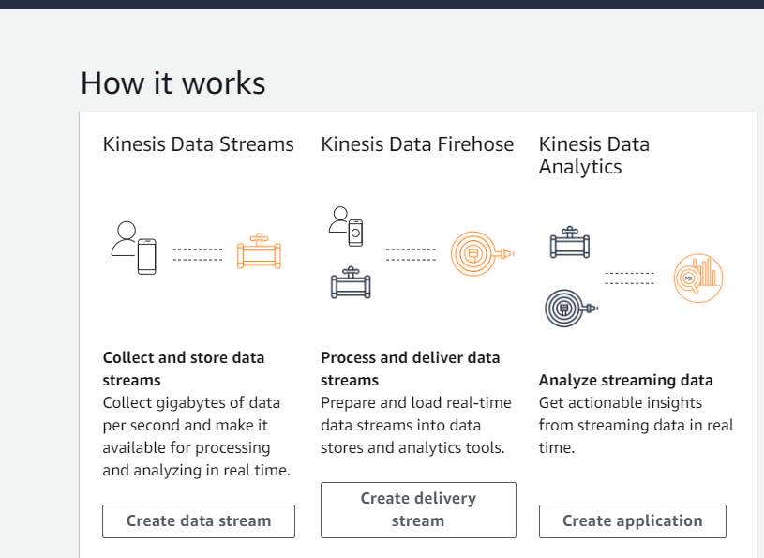

Click create data stream

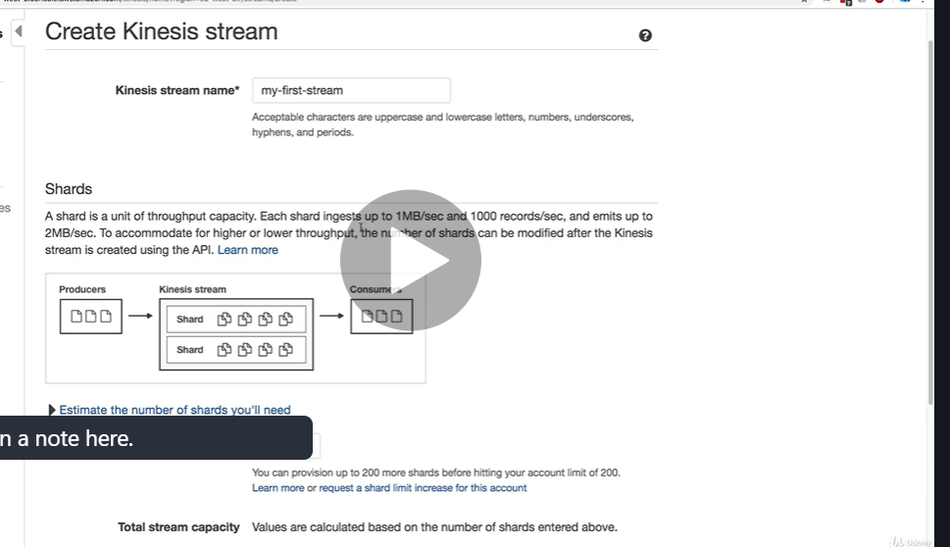

Click create kinesis stream

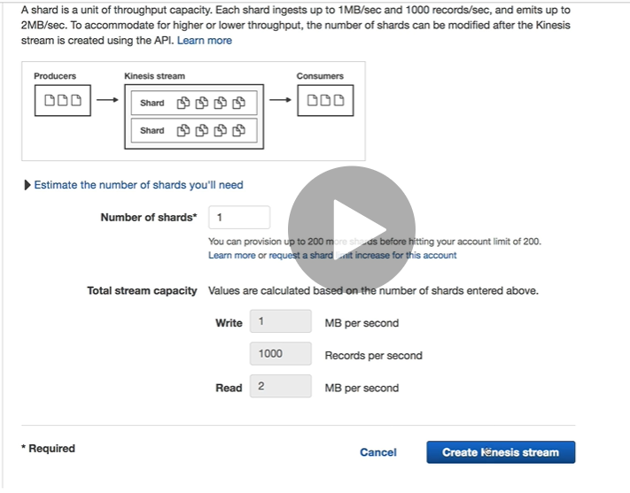

Stream is created

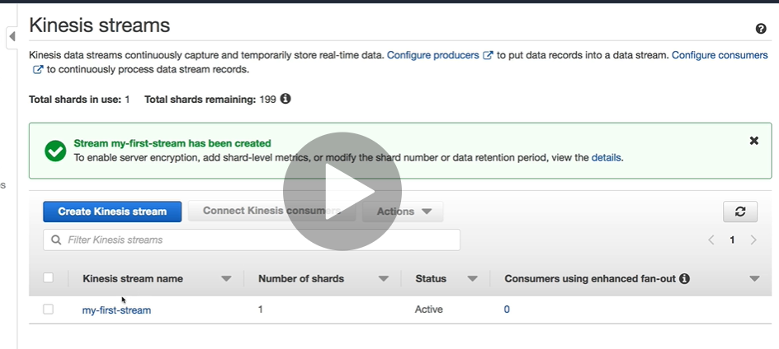

Click on it and see details:

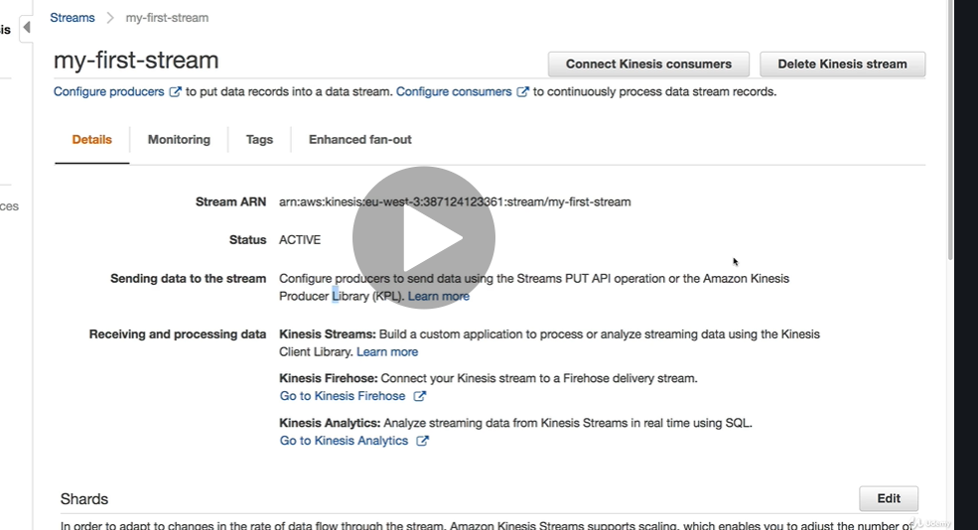

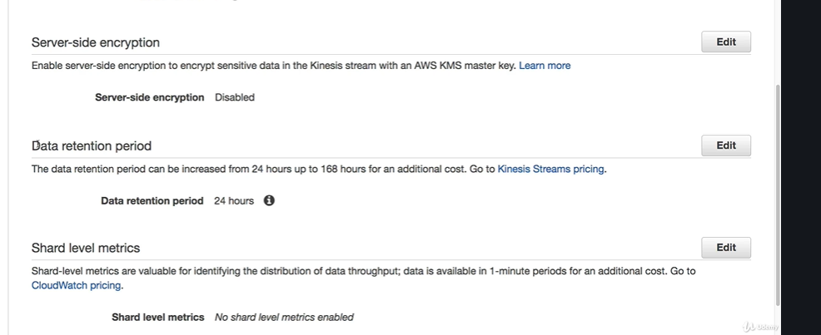

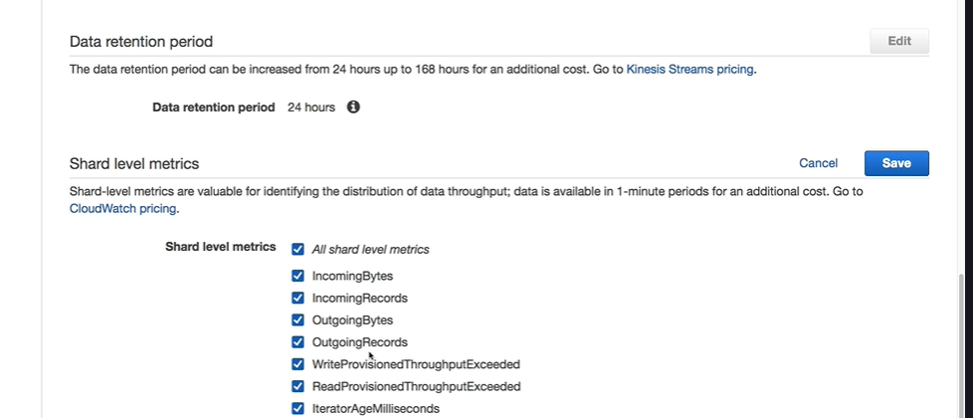

**Create stream from cli**

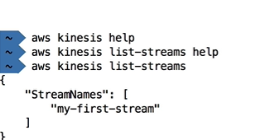

**More information will get**

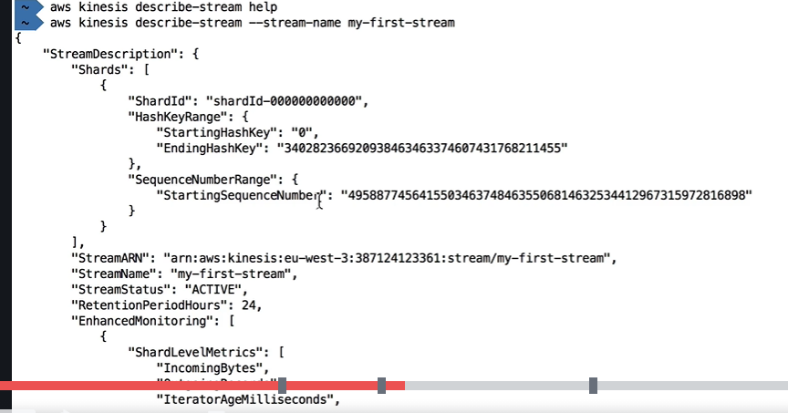

**Want to send data to shards:**

**Put record use to send data in stream**

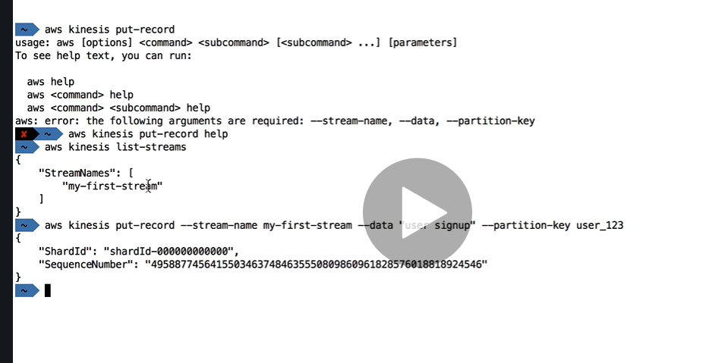

**Note**

**if we will send data using put_record we will get shard_id and sequence number**

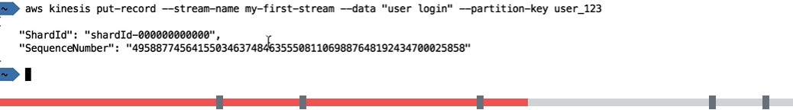

**Want to retrieve these records**

**Aws kinesis help:**

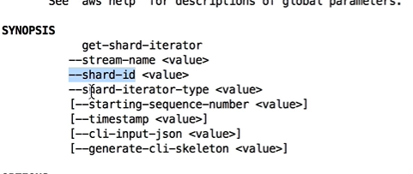

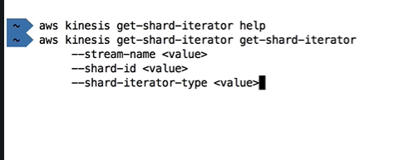

**To get shard id**

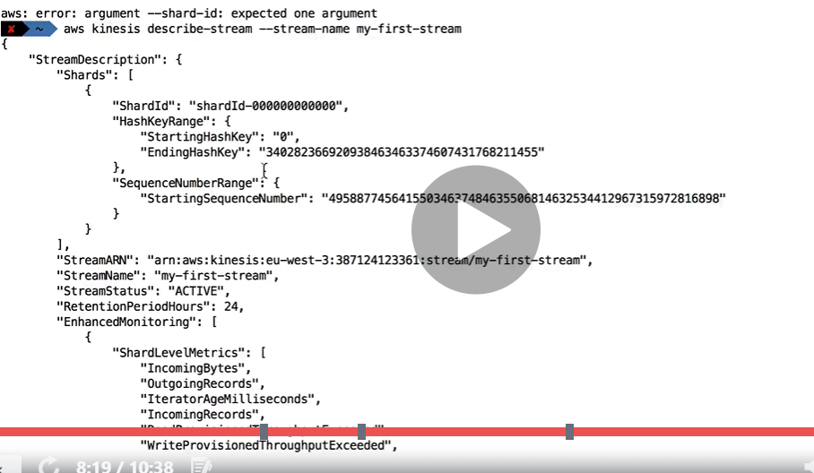

**After running below command we get shardIterator which will be helpful**

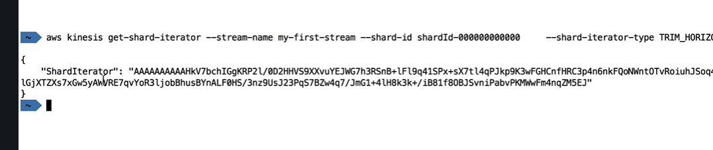

**After running below command we are getting three records**

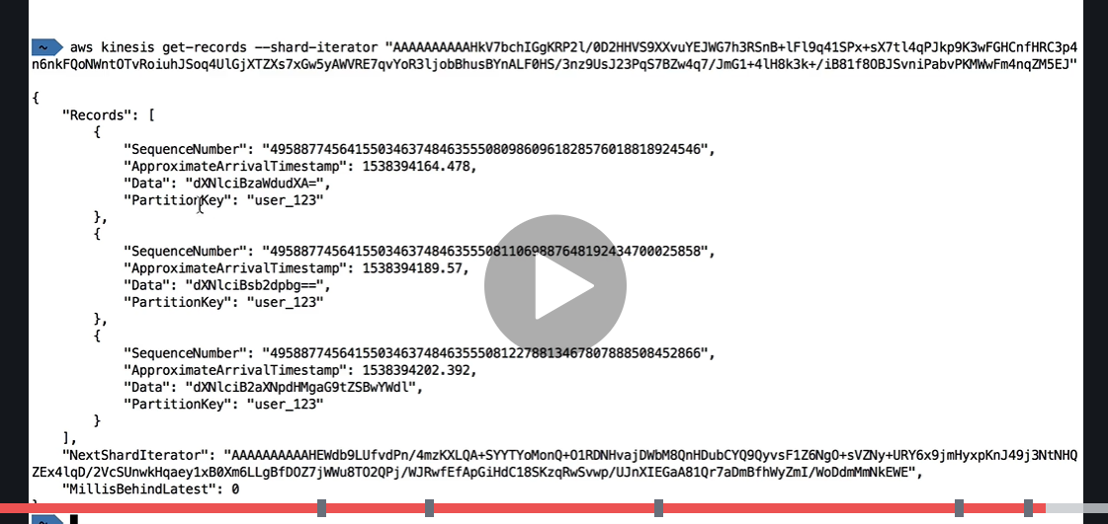

**Base 64 encoded data we need to decode it**

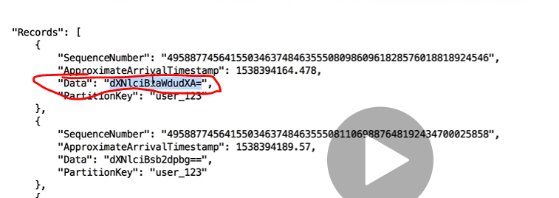

**Base 64 decode data**

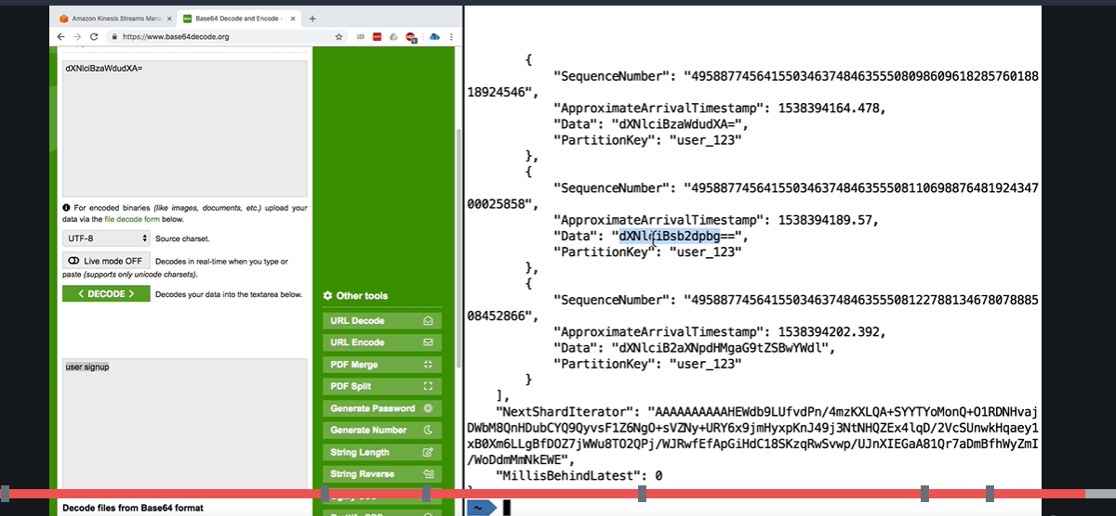

**AWS Kinesis KCL(kinesis client library)**

**Shard will be read by only one kcl as part of same application**

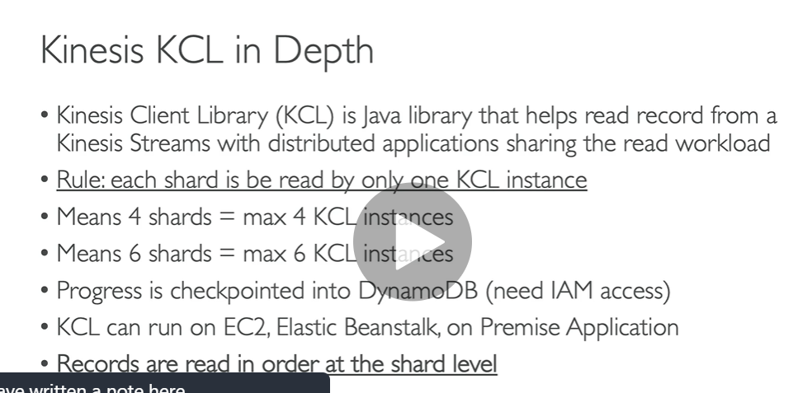

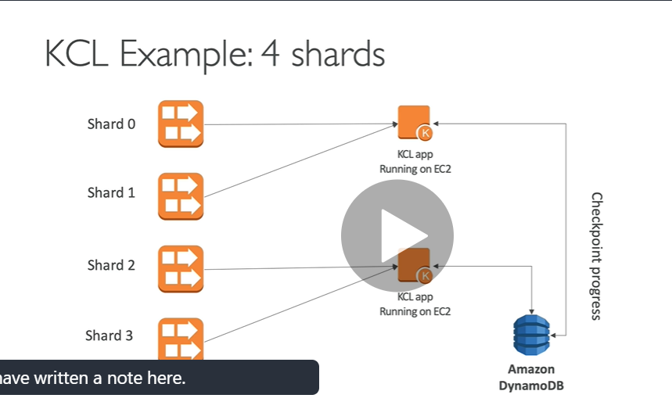

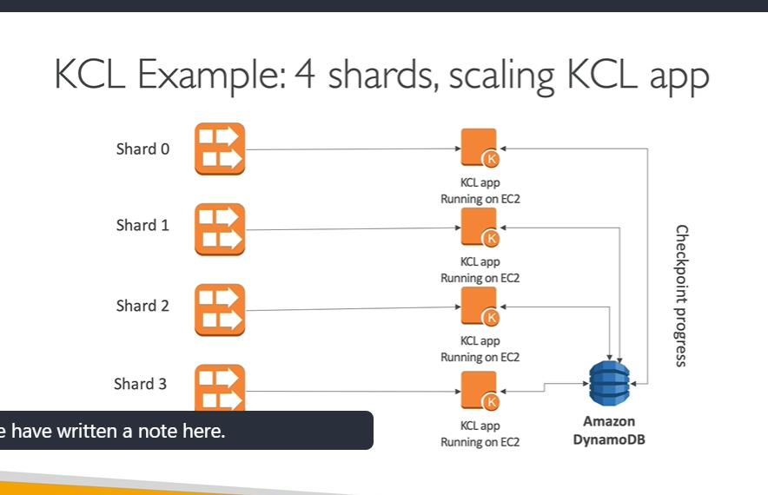

**We scale kinesis shard so we can also scale KCL application**

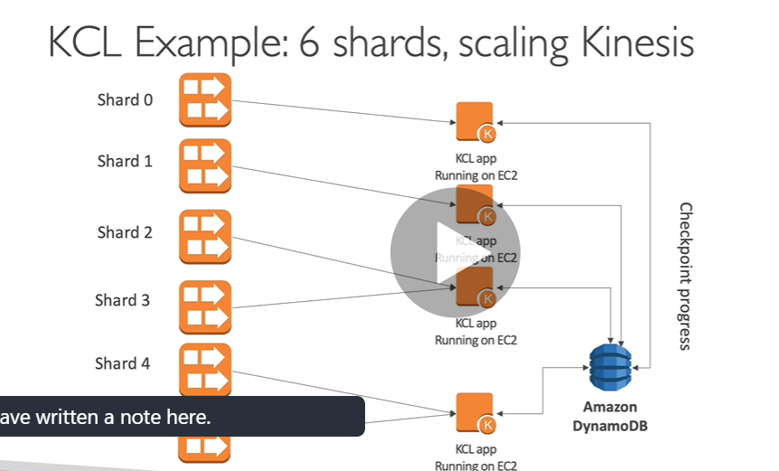

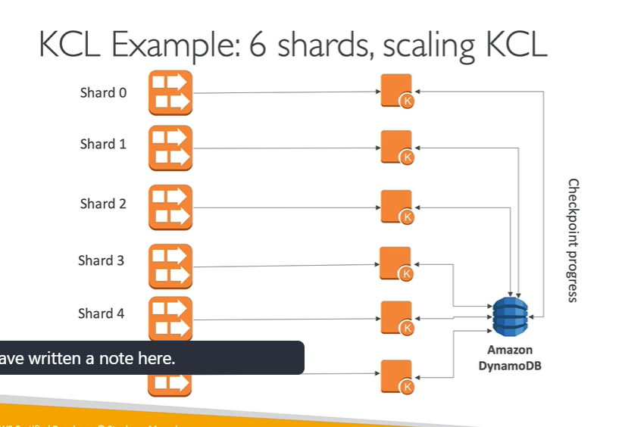

**Kinesis security firehouse and analytics**

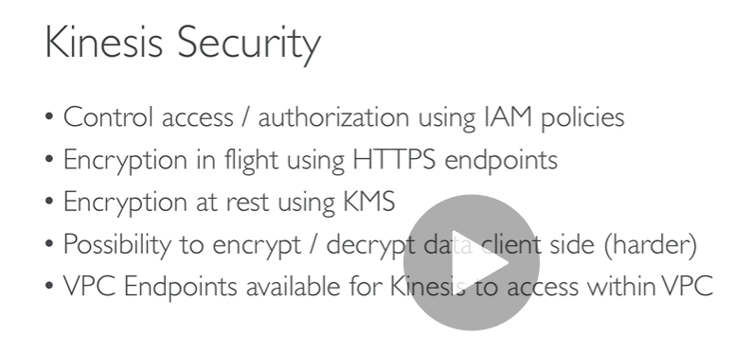

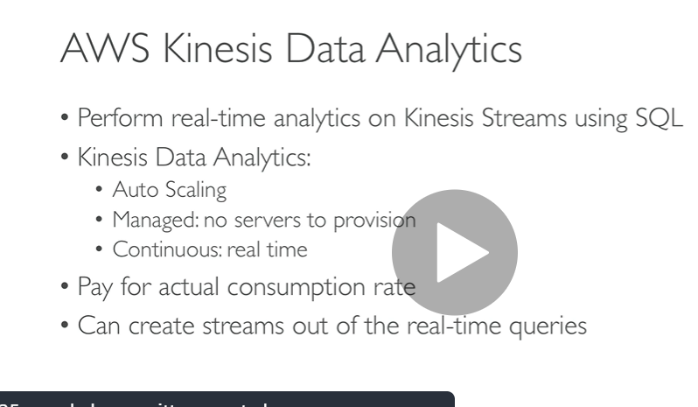

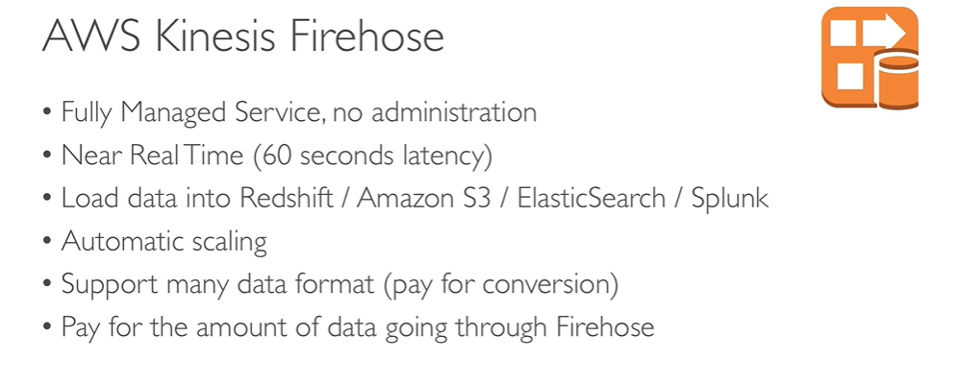

**SQS vs SNS vs Kinesis**

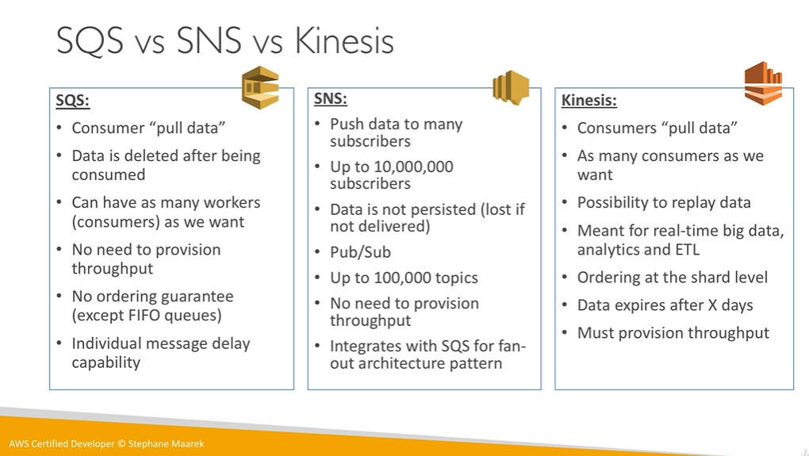

**Data Ordering for kinesis vs SQS Fifo**

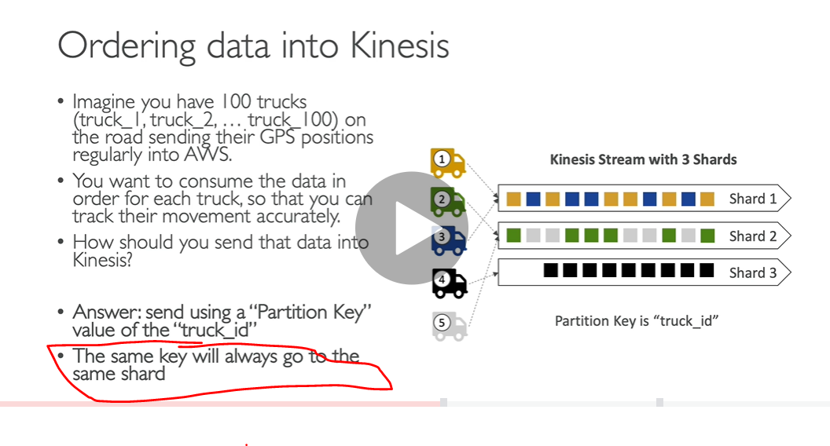

**The more group id we have the more consumer we have**

